ASKING THE QUESTION ABOUT VIOLENCE AND ABUSE IN ADULT MENTAL HEALTH ASSESSMENTS

Trainers’ notes
Introduction

This is the third edition of a course first delivered in 2006 to support the pilot implementation of routine enquiry (RE) across 15 trusts. The original course was based on training developed over many years by Chris Holley, Consultant Nurse, Sexual Abuse & Women’s Issues, South Staffordshire & Shropshire Healthcare NHS Foundation Trust, and refined following evaluation of the pilots. This revised version is based on research funded by the Department of Health in 2013/14: Responding Effectively to Violence and Abuse (the REVA study) which re-visited Trusts that had successfully maintained and supported routine enquiry over the last 5 years.

The purpose of the course is to help staff become more confident about asking in assessments whether clients have experienced violence or abuse at any point in their lives. The expectation is that, if they don’t already, they will begin asking ‘the question’ following the training.

In delivering this training you will make clear to participants that violence and abuse are part of the core business of mental health services. They are not an optional specialist interest, or issues to be passed on to colleagues in psychology or in the voluntary sector. This is not about ‘taking on new work’ – over half of the service users they currently work with will have experienced abuse in their childhood and over half their women clients are likely to have experienced violence from a partner - it is about recognising that the needs of survivors have previously not been met by mental health services.

Course participants will gain a clear sense of why and how abuse and violence impact on mental health and appreciate that service users with a wide range of diagnoses can have underlying abuse issues.

The biggest barrier to many staff asking ‘the question’ is feeling ill-equipped to say or do the right thing if the answer is ‘yes’. They should finish the day feeling much more confident about how to: ask the question, respond helpfully and follow through on a disclosure to address the safety and support needs of their clients.

Participants will go away with a better understanding of some of the common consequences of violence and abuse that survivors struggle with. They will be clear that not all survivors need or want formal therapy, and that all mental health staff have an important role to play in providing the support survivors require. They will have been encouraged to use support, supervision and further reading to develop their understanding and their skills.

About these notes

These notes are intended to be used in conjunction with the powerpoint presentation provided and comprise:
- A ‘script’, which appears between speech marks (“ “). This is not intended to be read out but is provided as a ‘crib sheet’ for new trainers and for those occasions when you’ve forgotten what you were going to say next (it happens to all of us!).
- Instructions in bold.
- Additional information for trainers, references and links to useful websites in italics.

There are two blank slides (55 and 57) in the presentation where you will need to insert information specific to your trust.

Suggested timings appear at intervals to help you keep on track. These timings assume a start time of 9.30am and a finish time of 5.00pm allowing an hour for lunch.

A number of case examples are included at the end of these notes (pg 63). These are for use in the exercises or where an example might be used to illustrate a particular point. Case examples are important as they bring the issues alive and help participants connect with the lived experience of survivors. Use your own examples instead if you have them, but do remember to make sure they are sufficiently disguised to ensure client confidentiality.

Survivors’ testimonies are very powerful and there are many ways of encouraging staff to connect with these. A 45-minute DVD ‘Not Mad or Bad but Traumatised’* includes testimony from a number of survivors of child sexual abuse who are also users of mental health services. It was produced in 2008 by CIS’ters, in conjunction with CSIP South East, and a copy was been sent to the Chief Executive of every Mental Health Trust in England. You can order a copy (£12 including postage) from *CIS’ters SEDC - CSIP PO Box 119 3000 Cathedral Hill Eastleigh Guildford Hampshire Surrey SO50 9ZF GU2 7YB Tel: 02380 338080 Email: admin@cisters.org.uk

Organising a lunchtime screening of the DVD can be a very effective follow up to the training – consolidating learning and encouraging networking.

There is a recommended reading for trainers list at the end of these notes (pg 67). We have tried to include the most up to date and recent literature we think you will find of use. We have prioritised readings that are accessible in the way they are written and those that can be downloaded from the web. In addition there are a few things that trainers should familiarise themselves with prior to their first delivery:

- The four briefings from the REVA study:
REVA Briefing 1 Violence, Abuse and mental health in England.
REVA Briefing 2 Implementing and sustaining routine enquiry about violence and abuse in mental health services
REVA Briefing 3 Why asking about abuse matters to service users
REVA Briefing 4 What do survivors of violence and abuse say about mental health services?

These briefings will be published in early 2015 and available at www.dmss.co.uk. They are the background reading for this course and you should include this link in a pre-course email to all participants.

- Your own trust’s safeguarding policies and procedures for children and vulnerable adults. The trust safeguarding lead should be actively involved in the development, support and monitoring of RE and aware that the training is taking place. They will be able to alert you to any current cases/issues involving local services which you need to be aware of. Department of Health guidance on the role of health service workers in safeguarding adults is available at: https://www.gov.uk/government/uploads/system/uploads/attachment_data/file/215714/dh_125233.pdf

- Your trust’s complaints and whistle-blowing procedures in order to address any questions relating to disclosures of abuse perpetrated by mental health professionals. The Sexual Offences Act 2003 contains specific offences that relate to breach of trust by care-workers, specifically including engaging in sexual activity with someone with a mental disorder.

- The different ethnic and cultural backgrounds of service users and staff in your trust and the issues pertinent to different groups. You may find it helpful to discuss the implications of these for providing support to survivors with colleagues and service users from backgrounds other than your own, and to make contact with BAME groups and services .

- Local and national services for survivors of violence and abuse. The key national services that all mental health staff should be aware of are:

The freephone 24 hr National Domestic Violence Helpline 0808 2000 247 run by Women’s Aid

Rape Crisis national helpline freephone helpline 0808 802 9999
12 - 2.30pm and 7 - 9.30pm daily

The NAPAC (National Association for People Abused in Childhood) freephone helpline 0808 801 0331 (10am to 9pm Monday to Thursday and 10am to 6pm on Friday)

Survivors UK (for male survivors of rape and abuse) has a webchat service as well as a helpline on 08451221201 (reduced cost calls from landlines). Opening hours vary for these services so check their website: http://www.survivorsuk.org/web-chat/

The NSPCC FGM helpline: 0800 028 3550
or email fgmhelp@nspcc.org.uk

- Practice Guidelines on The Provision of Therapy for Vulnerable or Intimidated Adult Witnesses Prior to a Criminal Trial are available at:
http://www.cps.gov.uk/publications/prosecution/pretrialadult.html
These guidelines advise on the conduct of therapy if a prosecution is going forward. They suggest that clients should not be encouraged to discuss the evidence in therapy prior to the trial. They suggest the avoidance of certain kinds of therapy including hypnotherapy, psychodrama, regression techniques and unstructured groups. They were produced in response to the recognition that witnesses, including vulnerable or intimidated adult witnesses, had been denied therapy pending the outcome of a criminal trial for fear that their evidence could be tainted and the prosecution lost. This had been occurring in reaction to challenges to the validity of recovered memories in cases of historical abuse.

The guidelines are intended to ensure that survivors can still access therapy but of a kind which is unlikely to risk their memories being ‘contaminated’ or ‘therapist induced’. They should be accessed by anyone who is supporting a client during their - often traumatic - journey through the criminal justice system.

This third edition of the course has been designed and produced by Dr Sara Scott (DMSS Research) and Dr Jennie Williams (Inequality Agenda) who have been training mental health professionals together since 1999. Enquiries about this course and other training available on gender, violence and abuse can be directed to them:

Sara Scott

sara@dmss.co.uk
www.dmss.co.uk

Jennie Williams

jennie@inequalityagenda.co.uk

www.inequalityagenda.co.uk

November 2014

Course programme
Morning
Why routinely enquire about violence and abuse?

- Introduction to the day (9.30 a.m.)
Aims
Course outline
Learning outcomes
Before we begin….
- Why ask the question? (10am)
What are we talking about?
Who are we talking about?
Exercise: who is at risk?
Recognition in services
How common is violence and abuse?

Coffee break (11am)

The impact on mental health
Coping and diagnosis
Why RE matters

Lunch (12.30)

Afternoon
How do you ask clients whether they’ve experienced violence or abuse?
How should you respond to a disclosure?

- How to ask the question (1.30pm)
Trial run
Record keeping
Understanding disclosure and non-disclosure
Exercise: disclosing abuse

Tea break (3pm)

- Responding to a disclosure
Providing support to survivors
Safety planning
Specialist services
Support for staff
Close and evaluation (5pm)

Slide 1

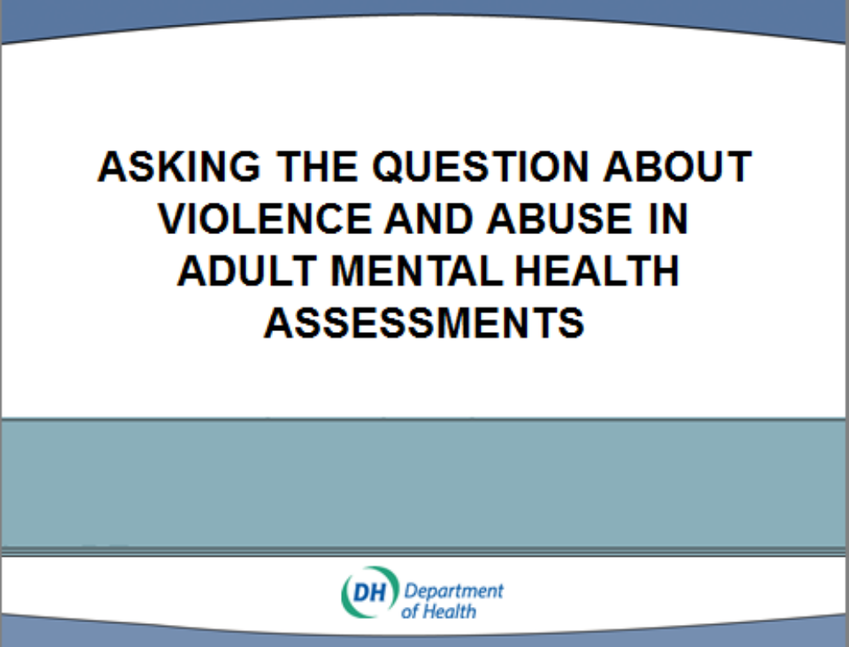

Slide 2

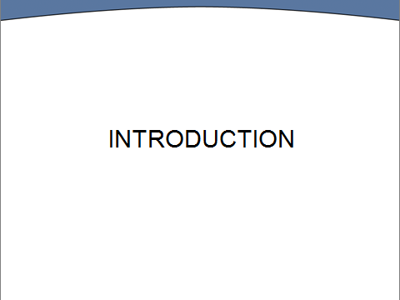

Slide 3: Time – 9.30am

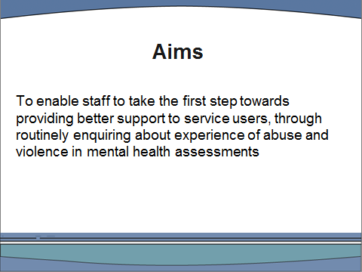

Slide 4

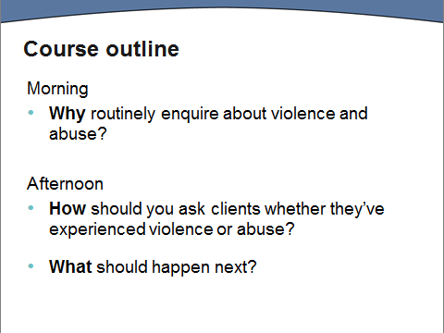

Slide 5

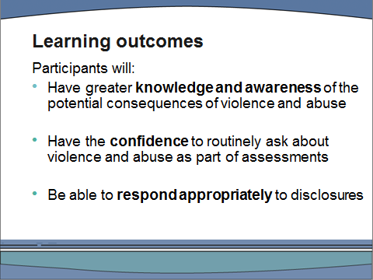

“These are the learning outcomes for today. The course is intended to give you the confidence to ask the question about violence and abuse in all mental health assessments.

Some of you may already have considerable expertise in supporting survivors of violence and abuse; for others, this will be the start of your learning. However, it is important that everybody receives the same training so that we share a common understanding of the purpose of routine exploration. The course is not intended to teach you new therapeutic skills. You already have the skills you need to respond appropriately to survivors of abuse. By the end of the day we hope you will feel more confident to use them.”

*For a summary of the evidence base for routine enquiry direct participants to REVA briefing No. 2

Slide 6: Time – 9.45 am

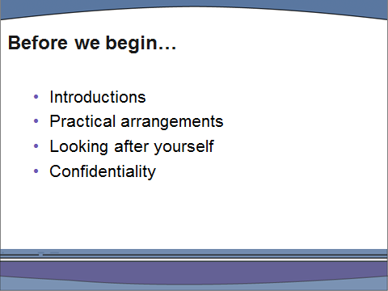

- Trainers need to introduce themselves with some information about their professional background and relevant experience.
- Trainers should then invite participants to briefly introduce themselves. Give times of breaks for lunch, tea-breaks and end time. Cover location of toilets, fire procedures, mobile phones etc. Emphasise that participants need to stay for the whole day.
- You need to cover issues of confidentiality and acknowledge that there may well be survivors of violence and abuse in the room.

“This course deals with issues which you may find troubling and distressing. It is therefore important that you look after yourselves during the day. The chances are that there will be people in the room with personal experience of violence and abuse so please be sensitive to that likelihood during our discussions. If anybody needs to take time out, please do so. Just come back when you’re ready. If the training raises any issues for you personally then we would encourage you to discuss these with a colleague, supervisor or line manager.

We will be using some anonymised case examples during the course of the day. If you want to share examples from your own experience we welcome that, but please ensure you do this in a way which protects the confidentiality of the service user concerned.”

Slide 7: Time – 10 am

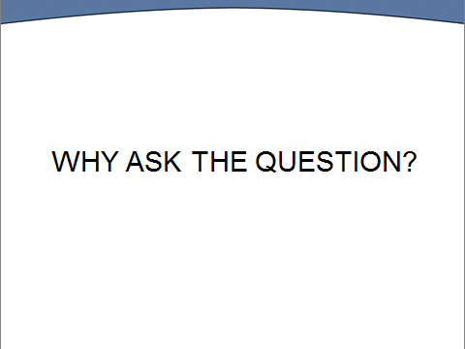

Slide 8

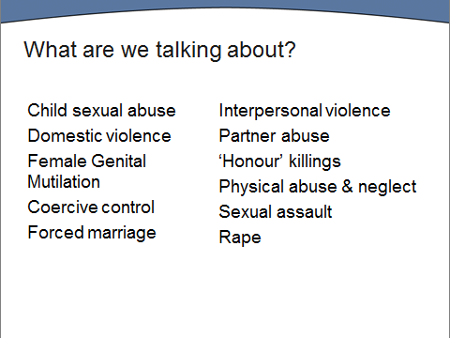

“There are lots of different terms used in this field. For example: domestic violence, intimate partner violence, domestic abuse and family violence are all widely used and child sexual abuse has historically been discussed as incest, paedophilia and child molestation – when it has been discussed at all. The terms on this slide cover the range of experiences that today’s training refers to.”

Slide 9

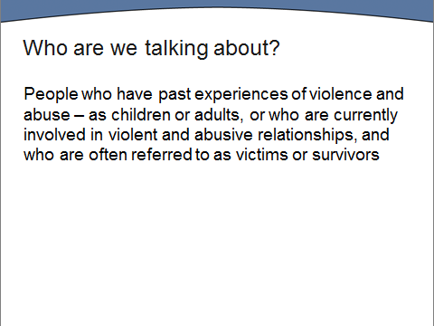

“We are talking today about people who were abused as children, people who have been raped or forced into sexual relationships (whether through forced marriage or sexual exploitation) and those who may currently be experiencing violence, coercion and abuse from someone they live with or are involved with”.

Small group exercise

Display slide 10. Divide participants into groups of four and ask them to do a quick list of those they think are likely to be most vulnerable to violence and abuse.

Slide 10

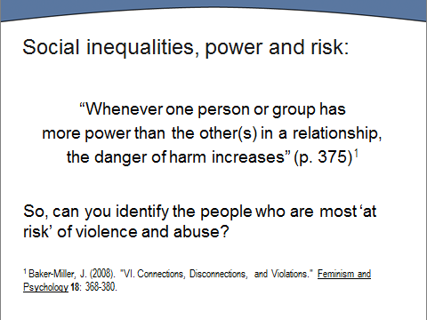

Take brief feedback on the groups identified and participants’ reasons for considering them at risk. Thank them for their thoughtful contributions and willingness to share them with each other. (The purpose of this exercise is to get people talking to each other and feeling confident about discussing the issues.)

Slide 11

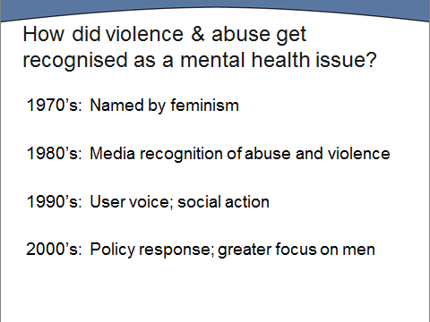
“Violence and abuse has always existed. However, it wasn’t until the Women’s Movement in the 1970’s that domestic violence and a little later child sexual abuse began to be widely talked and written about. These issues didn’t receive much media attention until the 1980’s when Esther Rantzen’s “That’s Life” programme was the first to bring the issue of sexual abuse to a wide audience. Out of this ChildLine was born and today these topics regularly feature in soap story lines, on talk shows and in numerous autobiographies and self-help books.

In the 1990s many mental health service users found a voice and started to press for services that were more responsive to their needs and which acknowledged them as partners in their treatment. Organisations such as WISH (Women in Secure Hospitals) commissioned research and developed training for staff around abuse and self-harm.

This particular training initiative originates in the Implementation Guidance: Mainstreaming Gender & Women’s Mental Health, (Department of Health, 2003). Although this was in the context of the development of women’s mental health services, Department of Health policy makes it clear that the question should be asked of both women and men, and in the last decade there has been an increased focus on the impact of violence and abuse on men’s mental health.

See also Informed Gender Practice: Mental Health Acute Care that works for women, NIMHE/CSIP, 2008 https://www.nacro.org.uk/data/files/nacro-2008080100-98.pdf

Slide 12

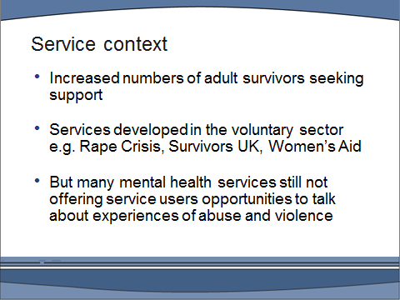

“
As awareness has increased, so has the number of people seeking support to deal with their abuse experiences. Much of this support has been provided by the voluntary sector. A network of Women’s Aid Refuges, Rape Crisis Centres and survivors groups has provided support in the voluntary sector since the late 70s, and today The Survivors Trust is an umbrella organisation which embraces 80 + voluntary services.*

Whilst there have been mental health practitioners working in this area for many years, the extent to which survivors have been appropriately supported within statutory services has varied considerably. Many service users have described negative and unhelpful responses from mental health services and few practitioners have had any formal training on issues of violence and abuse.

The aim of this training is to improve the service that survivors receive from mental health services and ensure that they are able to fulfil their responsibility for meeting the needs of adult survivors on their caseloads. Of course service users have choices and may wish to use voluntary sector provision and it’s important that you are aware of services in this sector. However, practitioners should not simply refer on to the voluntary sector. This is core business for us within mental health.”

*www.survivorstrust.org.uk includes a directory of services around the country and useful self-help information.

Slide 13

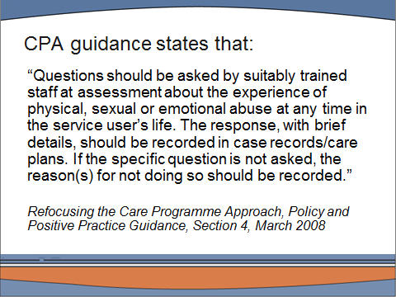

“This guidance reflects Department of Health policy on routine enquiry in mental health services. The policy of implementing RE and embedding it in clinical practice in adult services was piloted in 15 mental health trusts between 2006 and 2008. The pilot was evaluated and national roll-out, supported by a previous version of this training, commenced in 2009. Of course, the issue is relevant in all services that mental health trusts deliver including those for older people, those with learning disabilities etc. The expectation was always that the process would move into these services in due course and in some Trusts/this Trust it has done so.

One simple answer to the question ‘why ask the question?’ is therefore that it is DH policy and it is required that all staff conducting adult mental health assessments ask it.

Why has it become DH policy to ask the question? Because there is evidence that many mental health service users have experienced violence and abuse in their lives and that this has contributed to their mental health difficulties. There is also evidence that service users welcome being asked and that asking routinely can be effective in identifying and meeting needs appropriately.

Exercise in pairs
“Why do you think the policy of routine enquiry is not always implemented? (Why does the question not always get asked?) Talk with the person sitting next to you about what you think the barriers are”

Take feedback and show slide

Slide 14: Time – 9.55

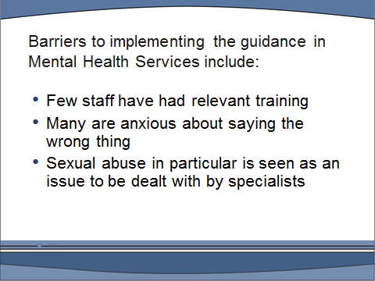

At this point trainers can ask participants how many of them received any formal training on the impacts of violence and abuse as part of their professional training or induction to working in mental health services.

“The growth in awareness of abuse in society at large means that many service users arrive at mental health services expecting to be asked about their history of abuse.* However, many mental health professionals still don’t readily discuss abuse with their clients. The evaluation of implementation in the pilot trusts found that most staff knew a great deal more than they thought they did about violence, abuse and the mental health impacts of such experiences, and that gaining more confidence to use their existing skills was more important than increasing their specialist knowledge. This is one of the main purposes of today’s course”

Case example 1 provides three examples of the implications for survivors of not being asked the question – or having their disclosures ignored.

*If trainees want evidence that survivors want to be asked about abuse in mental health assessments, refer them to REVA Briefing 3: Why asking about abuse matters to service users: A briefing for mental health professionals

Also two studies by Sarah Nelson (2001) Beyond Trauma: Mental health care needs of women who survived childhood sexual abuse, Edinburgh: Health in Mind. And a recent publication Sarah Nelson and Health in Mind (2013) Working with Male Survivors of Childhood Sexual Abuse: Understanding Me: http://www.health-in-mind.org.uk/assets/files/Understanding%20Me_webedition%20(2).pdf
Sarah wrote one of the first UK books to be published in the UK on the subject of sexual abuse: Incest Fact and Myth (Glasgow: Stramullion, 1982).

Slide 15

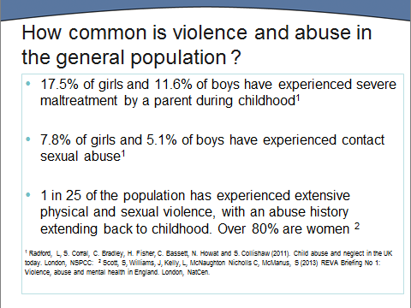

Slide 16

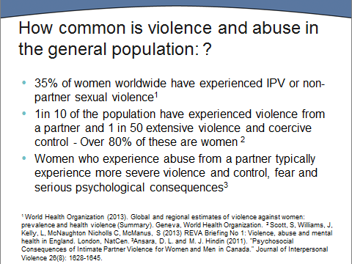

“If experiences of violence and abuse in childhood and adulthood are this common in the general population how common do you think they are amongst mental health service users?” You may want to ask people to estimate the proportion of their clients that are survivors of child sexual abuse or have experienced domestic violence. “On the next two slides are some of the research findings:”

Slide 17
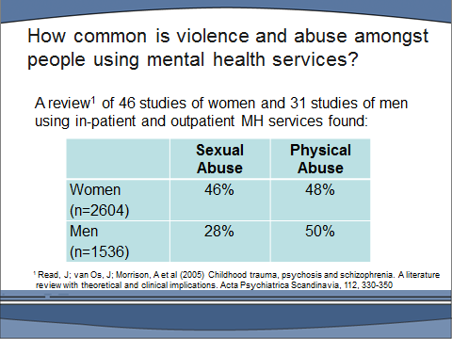
“It is likely that just under half of the women and over one-quarter of the men you work with will have been sexually abused in childhood and half of all clients will have experienced physical abuse as children*. These figures make it quite clear that abuse should be part of the ‘core business’ of mental health services.”

*Read, J; van Os, J; Morrison, A et al (2005) Childhood trauma, psychosis and schizophrenia. A literature review with theoretical and clinical implications. Acta Psychiatrica Scandinavia, 112, 330-350.

Slide 18:

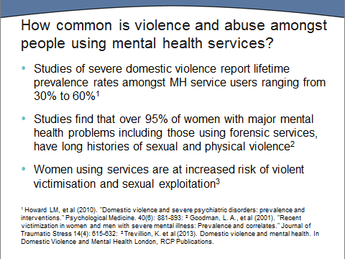

“Research on the prevalence of different kinds of violence and abuse is challenging, not least because respondents may be reluctant to disclose their experiences to a researcher. In addition, different studies use different definitions (for instance studies of child sexual abuse may include or exclude non-contact abuse such as ‘flashing’ or making a child watch pornography). Studies have used different data collection techniques (including questionnaires, telephone surveys and life-history interviews) different samples and different age cut-offs (under 18 or under 16 for child abuse or over 18 or over 12 for relationship violence). Not surprisingly therefore, estimates of prevalence vary. Because prevalence studies rely on respondents’ willingness to disclose it is also likely that they under-estimate some kinds of abuse and that some categories of victim e.g. boys are more likely to under-report. However, most estimates do agree that girls are generally at greater risk than boys, and there are gender differences in terms of likely age and relationship with their abuser. Girls are more at risk at a younger age and in familial settings whereas boys are more at risk at an older age and in non-familial settings.”

For a discussion of the wide range of estimates in relation to child sexual abuse see David Finkelhor, The International Epidemiology of Child Sexual abuse, in Child Abuse and Neglect, 1994, 18 (5).

“All these studies are based on self-report and people do not always name what has happened to them as ‘abuse’. Different cultures and legal systems define these things differently as well. For example legislation relating to sex and sexual offences varies from country to country. In Spain, for example, the age of consent is 13 (14 in Italy, 17 in Texas and 20 in Tunisia) reflecting prevailing attitudes towards young people and sex in different societies.

In addition, what counts as sexually abusive is culturally variable. Female genital mutilation is illegal in this country but still quite widely practised in the name of custom, religion and hygiene in several countries, particularly Egypt, Ethiopia, Somalia and the Sudan.* Peoples’ experience and understanding of what has happened to them (including whether they name it abuse or not) varies a great deal. It is important to remember this, particularly when working with clients whose background or culture differs from your own.”

*Research with 79 victims of FGM found that female genital mutilation is likely to cause various emotional disturbances, forging the way to psychiatric disorders, especially PTSD. The high rate of PTSD of more than 44.3% in the investigated group is comparable to the rate of PTSD of early childhood abuse. Symptoms of depression, psychosomatic conditions, sleep disturbances, and PTSD were found to be above normal levels. Despite the fact that female genital mutilation constitutes a part of the participants' ethnic background, the results imply that cultural embedment does not protect against the development of PTSD and other psychiatric disorders. Jan Ilhan Kizilhan (2011) ‘Impact of psychological disorders after female genital mutilation among Kurdish girls in Northern Iraq’ The European Journal of Psychiatry, 25 (2)
http://scielo.isciii.es/scielo.php?pid=S0213-61632011000200004&script=sci_arttext

For further information on FGM see Forward website: www.forwarduk.org.uk or the Royal College of Nursing educational resource on FGM is available at: http://www.rcn.org.uk/__data/assets/pdf_file/0012/78699/003037.pdf

Coffee break 11am

The impact on mental health

Slide19: Time – 11.15am

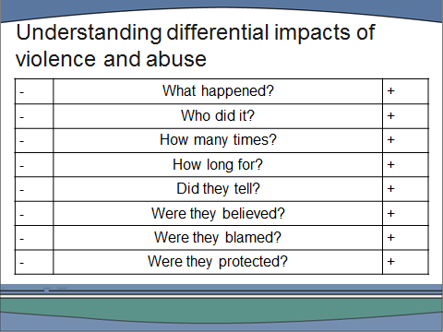

Instead of using this slide you may want to draw this on a flipchart (you can prepare this in advance). Having a break from Powerpoint helps to maintain the concentration of trainees.

“There are many different kinds of abuse. Of course, what happened and its severity is a key factor, but there are a number of other factors which are likely to increase (+) or reduce (-) the impact of abuse*. A longer duration of abuse has consistently been shown to be associated with more negative outcomes for victims. Research has also shown that repeat victimisation is, unsurprisingly, also associated with more negative outcomes.

For example, imagine that when you were 12 you were flashed at in the park by a stranger, you went home and told your Mum. She believed you and phoned the police. The police believed you and arrested the man who then pleaded guilty. Contrast this with a child who is sexually abused by her step-father repeatedly over many years. At 14 she tells her mother who accuses her of lying. She spends the rest of her teens in care and is abused again by a residential care worker.

The long-term impact in the first case is likely to be nil, while for the second it could be profound. Many survivors who end up needing to use mental health services have complex family histories and multiple experiences of abuse. They may also have faced disbelief and rejection rather than support.”
Alternatively, you may want to contrast two different experiences of an abusive adult relationship. One short-term: where the victim quickly recognises that her new boyfriend’s behaviour is controlling and who seeks help the first time he assaults her and when he starts sending threatening texts gets an injunction against him. And one long-term: where the victim is gradually isolated from friends and family and once married begins to believe she is weak, stupid and incapable of living without her husband.

You may want to use a case example 5 to illustrate the importance of being believed and supported in mitigating or exacerbating the impact of abuse on someone’s mental health.

*Finkelhor and Browne (1986) produced an explanatory framework for the differential impact of child sexual abuse which consists of four ‘traumagenic dynamics’: traumatic sexualisation, stigmatisation, betrayal and powerlessness. They consider that much will depend on the child’s age and stage of development and on the amount of force used and fear invoked. Subsequent research reviewed by Tyler (2002) bears this out, showing that the severity of the abuse, use of force and the victim’s relationship to the perpetrator are especially important.

Stigmatisation refers to all the negative connotations about the abuse that are conveyed to the child and become incorporated into the child’s self-image. These may come directly from the abuse, but they can also come from attitudes of peers, family and community. One aspect of this is the experience of ‘shame’, and Feiring and Taska’s (2005) research shows that this may be highly significant.

Betrayal refers to the experience of having trusted an adult who has abused that trust and again much depends on the nature of the pre-existing relationship with the abuser and on the degree of support from other, non-abusive carers.

K. Tyler ‘Social and emotional outcomes of child sexual abuse: A review of recent research’ Aggression and Violent Behaviour, 2002, Volume 7, pp. 567-589 C.
Feiring and L. Taska ‘The persistence of shame following sexual abuse’
Child Maltreatment, 2005, Volume 10, Number 4, pp. 337-349.
D Finkelhor, and A Browne ‘Initial and long-term effects: A conceptual Framework’ A Sourcebook on Child Sexual Abuse, 1986, pp. 180-198. Newbury Park, CA: Sage.

Slide 20
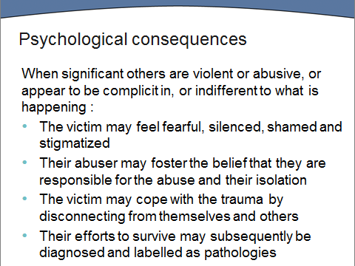

Slide 21: Time 10.40am

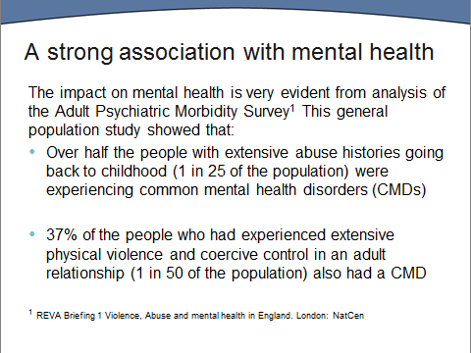

Slide 22:

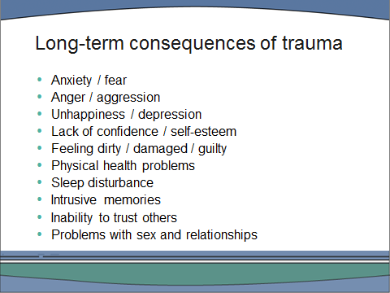

“There are many common consequences of trauma. Survivors using mental health services are often those with the most severe ongoing problems, but this is not always the case. As we have just seen, the impact of violence and abuse will vary according to a whole range of factors. However, the long term consequences can be disabling and you will all have worked with people affected in these ways – although you may not have known at the time that they had been abused.”

At this point you may want to ask the group how two or three of these consequences can be ‘caused by’ either physical abuse in childhood or rape as an adult: ‘Why do you think survivors often have difficulty trusting people? Why do you think some survivors feel so dirty?

“In providing care for survivors - particularly in an in-patient setting - it is important to avoid unwitting re-traumatisation. For example
- There can be a tendency for staff to disapprove if patients aren’t sleeping. However, a survivor of sexual abuse may need to stay awake until after the time of night that abuse used to happen, be fearful of sedation and distressed by staff doing observations at night, entering their rooms or sitting on their beds particularly if the staff member is the same sex as their abuser(s).
- Male survivors can feel particularly fearful on all-male wards.

Mental health services are not always good at recognising physical health needs. Some survivors have physical damage/disabilities resulting from their abuse and may need support to access appropriate services e.g. gynaecological, genito-urinary or for anal continence issues, for example.

Slide 23

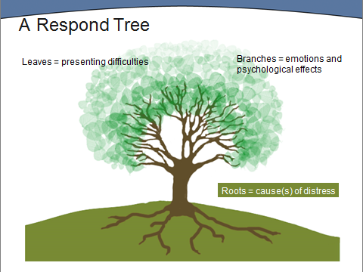

“Survivors often want to make sense of the role of their abuse in their current difficulties and it can be helpful to discuss the different ways people are affected by abuse, the coping mechanisms they may have developed, and the ways in which their difficulties have been labelled and treated within mental health services i.e. once we start ‘labelling’ people, the tendency is to focus on the label and not the person behind that label. This tree was designed by Respond* (an organisation specifically supporting people with learning difficulties who are affected by trauma or abuse) as a visual aid to help answer the question: “Why has it affected me like this?” You may find it a useful tool to help people you work with in making sense of the effects of abuse on their lives. “

*Respond have an excellent website: www.respond.org.uk

If you have a tool for direct work with survivors you prefer, you may want to insert it here in place of the Respond tree. In this case you will need to adapt the following exercise.

CASE STUDY EXERCISE

Divide into three or four groups, giving each a card with one of the following descriptions on it and a sheet of flipchart paper. Ask each group to draw what a respond tree might look like for their client.

- An asylum seeker in his fifties who has been a political prisoner in the Democratic Republic of Congo, and experienced torture.
- A woman in her late 30’s who met her partner on line and moved to the UK to marry him. He puts her down and is physically abusive.
- A teenage girl who has been sexually abused over a number of years by her older brother, and doesn’t speak of it to anyone.
- A young gay man who has been rejected by his family and is now financially and emotionally dependent on an older man.

Slide 24

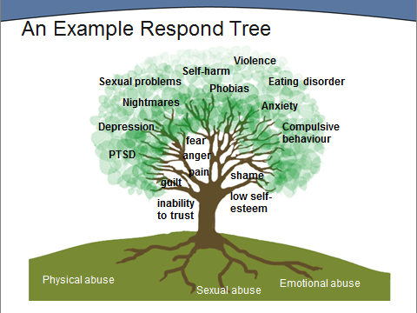

“The links between sexual abuse/inability to trust and sexual problems or between physical abuse/fear and compulsive behaviour may seem obvious to you but not to your client. A personal tree can be completed with a survivor to help them think about the relationship between their abuse, its impact on them and the difficulties they now have.”

“Your respond trees remind us of the ways that people actively struggle to survive and cope with the effects of abuse. Some of these are included on the following slide”

Slide 25

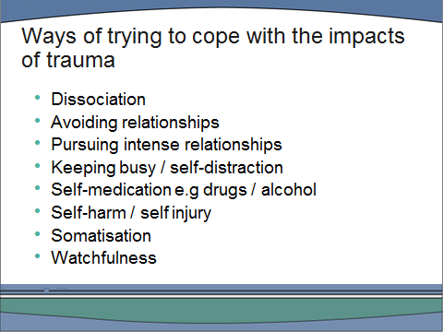

“Some coping mechanisms help survivors to avoid memories or thoughts e.g. keeping occupied all the time so there is no time to think or dissociating/‘blanking out’ when thoughts become too painful. Other mechanisms may be used to dampen down difficult feelings such as rage and shame e.g. abusing drugs and/or alcohol. Some survivors self-harm as a way of releasing painful emotions. Quite a lot of survivors somatise their distress and experience it as physical pain. This is particularly common among some cultural groups including South Asian women.* Many survivors who use mental health services are highly dissociative and may ‘space out’ and ‘lose time’ to avoid distress, or become so ‘taken over’ by memories and emotions that a dissociative state is sometimes interpreted as a psychotic episode. Abuse in childhood can seriously distort the development of a child’s personality, and in later life they run the risk as being diagnosed as personality disordered rather than been recognised as survivors of complex trauma”**

NB. You need to check that everyone in the group understands the term dissociation.

*Depression in South Asian Women Living in the UK: A Review of the Literature with Implications for Service Provision
Feryad Hussain and Ray Cochrane Transcultural Psychiatry, Vol. 41, No. 2, 253-270 (2004)
**Phil Mollen, 1996 Multiple Selves, Multiple Voices: Working with trauma, violation and dissociation. Chichester: Wiley
Staff and survivors may find the PODS (Positive Outcomes for Dissociative Survivors) website helpful http://www.pods-online.org.uk/

“In most mental health services all these survival strategies tend to be translated into diagnoses. Such as:

Slide 26

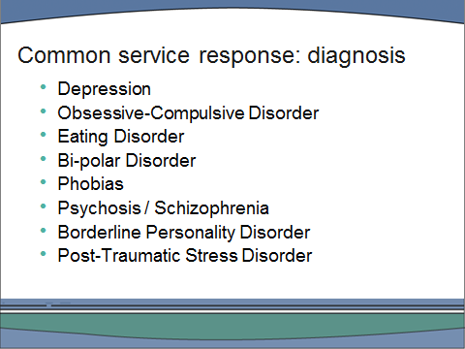
Case example 3:

Diagnoses address the question: ‘what is wrong with this person?’ rather than ‘what has happened to this person?’. We cannot go into details about each diagnosis today, but you may well have examples from your own experience of how particular difficulties may be rooted in experience of violence and abuse”

Use case example 3: Issues of control and ask the group how they think William’s OCD is rooted in his childhood experience. Ask if people have any examples of eating disorders or phobias related to abuse experiences.

“
There is also a growing amount of evidence that childhood sexual and physical abuse is related to the symptoms of psychosis and schizophrenia. For example a study of over 4,000 people in the Netherlands found that those who had suffered severe childhood abuse were 48 times more likely to have ‘pathology level psychosis’ than people who had not been abused as children”.*

It may be helpful to discuss case example 4: Psychosis and escape at this point.

*Janssen, I; Krabbendam,L; Bak, M, et al (2004) Childhood abuse as a risk factor for psychotic experiences Acta Psychiatrica Scandinavica, 109, 38-45.

For participants who want further information on the possible relationship between psychosis and abuse, refer them to:

Read, J., P. Hammersley and T. Rudegeair (2007). "Why, when and how to ask about childhood abuse." Advances in Psychiatric Treatment 13: 101–110.

Bebbington, P., S. Jonas, E. Kuipers, M. King, C. Cooper, T. Brugha, H. Meltzer, S. McManus and R. Jenkins (2011). "Childhood sexual abuse and psychosis: data from a cross-sectional national psychiatric survey in England." The British Journal of Psychiatry 199: 29-37 Available at: http://bjp.rcpsych.org/content/199/191/129.full.pdf+html.

“In most mental health services the role of trauma is mostly acknowledged where there is a diagnosis of PTSD”

Slide 27

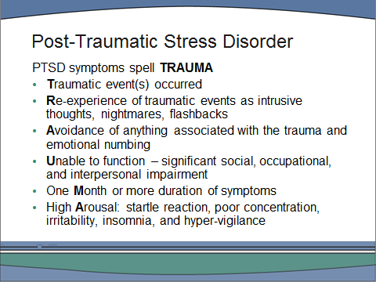

“PTSD is extremely common among survivors of violence and abuse but it is often not diagnosed as the patient has to first tell about the trauma before a PTSD diagnosis can be made. Studies have shown that child sexual abuse is associated with PTSD in adult women and that the severity of PTSD symptoms is associated with the extent of the abuse.** Similarly, studies of abused children have shown a link with PTSD.***

Adults who develop PTSD in the aftermath of a public disaster, or crime, may be provided with de-briefing/counselling. Many who suffer PTSD as a consequence of involvement in armed conflict or domestic abuse will suffer without external help or acknowledgement. Someone who has been in a ferry disaster might be hailed as a hero but also be troubled by PTSD symptoms e.g. fear of water, the avoidance of boats and have flashbacks triggered by media coverage of the disaster. It would not be difficult to explain this to friends and colleagues. Imagine how much harder it would be for a survivor of abuse to tell their partner that they are having flashbacks when they walk into a bathroom, collect their child from school or during sex.

PTSD symptoms can occur many years after the event.”****

Illustrate with c
ase example 5: Traumatic memories in her 80s

* This is the American Psychiatric Association’s mnemonic for the symptoms of PTSD. A simple mnemonic for the diagnostic criteria for post-traumatic stress disorder, H R Khouzam Western Journal of Medicine. 2001 June; 174(6): 424.

**What determines post-traumatic stress disorder symptomatology for survivors of childhood sexual abuse? L Briggs and P Joyce
Child Abuse and Neglect, 1997, Volume 21, Issue 6, pp. 575-582

***Relationship of attributional style, depression and post trauma distress among children who suffered physical or sexual abuse', M Runyon and M Kenny, Child Maltreatment, 2002, Volume 7, Issue 3, pp. 254-264.

**** NICE guidelines for the management of PTSD are available at www.nice.org.uk/CG26. The guidelines recommend that CBT or EMDR are appropriate interventions for PTSD.

Slide 28

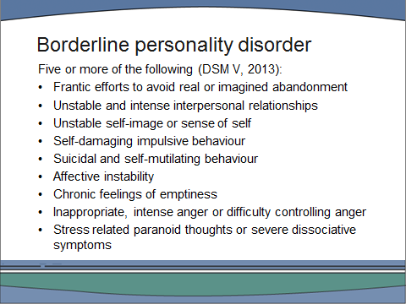

“Survivors in the mental health system often attract a BPD diagnosis. You can see that many of the traits listed reflect the long term consequences and coping strategies we have been discussing.* However, service responses can often be blaming and such clients can be seen as manipulative, controlling, attention seeking, difficult and aggressive/defensive/uncooperative.

Unlike PTSD, the BPD diagnosis makes no reference to the likely origins of such traits. Until very recently personality disorders have been ‘diagnoses of exclusion’ and have been seen as ‘untreatable’. Survivors often find a BPD diagnosis stigmatising and unhelpful; some clinicians consider that the term complex PTSD is more appropriate.”

*For a particularly insightful analysis of how abuse in childhood can shape the ways in which adults form relationships see: Judith Herman Trauma and Recovery, London: Pandora (1992) p111.

“The emphasis on diagnosis in mental health services means that the question of ‘what is wrong with people’ is seen as more important than what has happened to people. The implications of this for survivors of violence and abuse can be profound.

“What do you think the implications are for survivors if violence and abuse are not acknowledged by mental health services?”

Slide 29

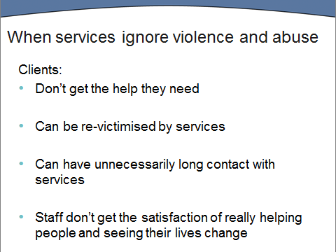

Slide 30:

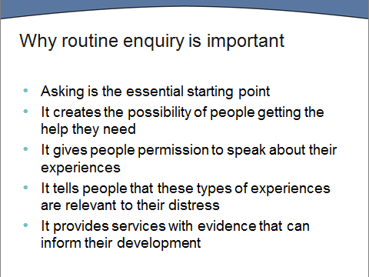

Slide 31

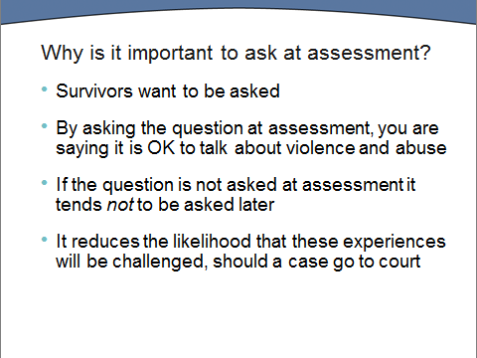
“The evidence is that survivors want to be asked about their experience of violence and abuse.* Asking at assessment gives service users the message that the significance of violence and abuse to people’s mental health is recognised and that the assessor is equipped to discuss such experiences if they wish. Not asking reinforces the message that many survivors will have heard from their abuser, that this is something not to be spoken about – so shameful that even mental health services avoid it.

It is important to ask at assessment as there is evidence that, if the question is not asked at initial assessment, it won’t get asked later**. Of course, there will always be occasions where it is not possible to ask at an initial assessment. Where this is the case the reason should be clearly recorded and the professional conducting the assessment needs to take responsibility for following up when the client is less distressed. Clinicians who have in the past waited until rapport was established before asking about experiences of abuse should consider that for many survivors, asking may be a crucial act that encourages rapport rather than a barrier to it.

Asking routinely in the course of an initial assessment also protects mental health professionals from accusations of having ‘asked leading questions’, ‘planted the idea in her head’ or ‘encouraged a client to construct false memories’. Where a therapeutic relationship has already been established, this may sometimes occur because a client may need and want to please a practitioner – as well as find an explanation for their own distress.

The accusation that a survivor is suffering from ‘False Memory Syndrome’ induced through therapy, reading self-help books or attending a survivors group has been a feature of the defence case for alleged abusers in some cases of historic abuse. There is an active False Memory Syndrome Association which supports people – particularly parents – who are accused of sexual abuse and often provides expert witnesses in court cases.***

Good practice in terms of:
- only asking ‘the question’ within an assessment and not as an isolated question, coupled with
- recording the content of a disclosure clearly - in the survivor’s own language or with clarification of detail

is protective of both client and professional should a case go to court.”

*Sarah Nelson (2001) Beyond Trauma: mental health care needs of women who survived child sexual abuse, Edinburgh: Health in Mind.

**A New Zealand study compared rates of disclosure when patients were asked about past trauma on admission or not. If asked on admission 47% disclosed sexual abuse, if not asked only 6% later disclosed either spontaneously or in answer to a later question. Read, J and Fraser, A (1998) Abuse histories of psychiatric in-patients. To ask or not to ask? Psychiatric Services 49, 355-359.

*** You can access information produced by the British False Memory Syndrome Association at www.bfms.org.uk. For critical perspectives on the concept of FMS in relation to survivors of child abuse see Phil Mollon Freud and False Memory Syndrome Icon Books (2000), or Sara Scott The Politics and Experience of Ritual Abuse, Open University Press, 2001 (Chapter 2). Or visit websites such as www.rememberingdangerously.com

Slide 32

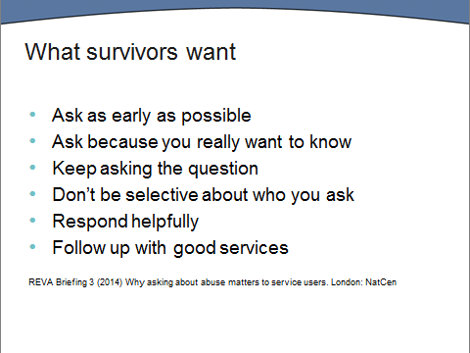

“Service users interviewed for the REVA research described how important being asked the question was for them. I’ll just quote one here:

“Bless her, I guess she knew the right questions that needed to be asked and it was the first time anybody had ever asked me…. [When she asked] I felt sick to my stomach. [ And] I thought, 'I'm - I'm going to have to get out of this room.' And then I thought, 'If you go out of this room, that's it. It's... you're never going to be able to go back.' So, I sat there and … then I got this feeling of relief to think that somebody had noticed that there was something very wrong … yeah, a - a feeling of absolute relief to know that I wasn't going to be burdened with it anymore.”*

And on that note we will break for lunch.”

*REVA Briefing 3 (2014) Why asking about abuse matters to service users

Slide 33: time – 12.30



Afternoon

Slide 34 Time: 1.30pm
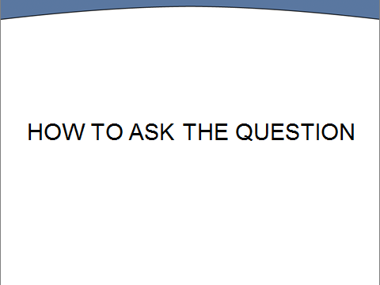

Slide 35

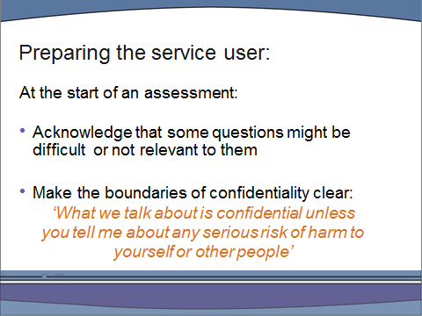

“It is always good practice to prepare the service user for the difficult questions which an assessment involves.

It is also good practice to inform service users of the limits to confidentiality at the outset. Make it clear that if, and only if, you are given specific details relating to a ‘risk of significant harm’ (such as names and whereabouts of an abuser in contact with children) you are obliged to pass these on. Clients will then be clear about what they can disclose.

It is important that the survivor feels a sense of control in the process, and you avoid the possibility that a survivor ‘discloses all’ but then regrets giving details that require staff to breach their confidentiality. In the majority of cases, in order to protect others who might be at risk, survivors will give details at a point when they are better prepared for the consequences.

Although it is not encouraged for service users to be accompanied during an assessment, this is sometimes the case and their partner or a parent may be present. In these circumstances the RE questions should be deferred.”

Slide 36

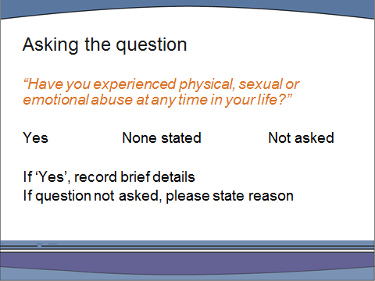

“This is the question as it should appear in your assessment documentation.
:
There should also be a space for you to record brief details of any disclosure and if the question was not asked, any reasons for this (e.g. carer/partner present during the assessment). The reason it is important to record ‘none stated’ rather than ‘no’ is because a service user may not choose to disclose at this time but do so later. If it ever came to court, a ‘no’ response in their records could be used to challenge the veracity of their claim. The question is also formatted like this so that it can be audited easily.

At this point, trainers should remind people where the question appears in their trust’s documentation and of the ways it is audited.

The aim is to keep the question simple and direct. It should be asked without preamble in exactly the same way, and in the same tone of voice, as all other questions within the assessment process. The evaluation of the pilot stage of initiative provided lots of evidence that staff often believe they are asking about violence and abuse, but are actually doing so in such an indirect way that they are unlikely to elicit much response. Tentativeness on the part of a professional suggests they are nervous of the subject and don’t really want to know.

Staff sometimes ask “If the patient is psychotic, would you still ask the question?”. Of course there are situations when a service user is too disturbed or distressed for an in-depth assessment to be undertaken.

There may be personal reasons why a particular member of staff does not feel able to work in-depth with issues of sexual abuse at a particular time. They may be a survivor themselves, or be supporting a friend or family member with issues of abuse. All staff are required to ‘ask the question’ in assessments but can then refer to a colleague to follow up if a disclosure takes place. This is no different to a practitioner who has recently been bereaved passing on a case involving bereavement issues.

If English is a not a service user’s first language, it is the trust’s mandatory obligation to provide an independent translator and not a member of their family or family friend, even if the service user seems happy with this. Wherever possible the translators used should be familiar with the sensitive questions asked in mental health assessments and comfortable in translating this particular question. They should also be provided with support. All translators are required to sign a confidentiality clause.”

Slide 37: Time – 1.50pm

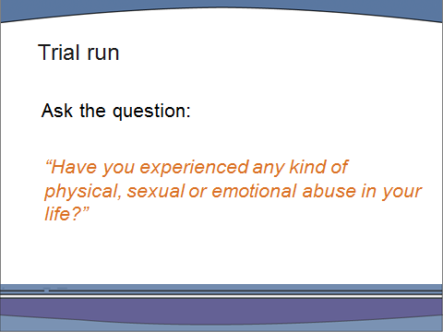

“You need to be clear about the kinds of behaviours that you are enquiring about. So, can someone quickly remind us about what is meant by physical, sexual and emotional abuse?”

Physical abuse and coercion
Includes: Threatening to hurt you, destroying objects that belong to you, threatening to kill you, standing over you, invading your personal space, threatening to kill themselves (and children), reading your emails, texts or mail, harassing you, following or stalking you. Controlling all the finances, making you account for every penny you spend, making all the major financial decisions.

Sexual abuse
Sexual assault is any kind of intentional sexual touching of somebody else without their consent. It includes touching any part of their body, clothed or unclothed, either with the body or an object.
The Sex Offences Act (2003) redefined rape as penile penetration of the mouth, anus or vagina. Causing a person to engage in any sexual activity without consent or administering a substance with that intent is also sexual abuse.
Non-penetrative sexual abuse includes sexual harassment, inappropriate touching, indecent exposure, being photographed or forced to watch or enact sexual acts without consent.

Emotional abuse
Includes: Belittling, sulking, blaming you for the abuse, making you think you are crazy by denying the abuse, degrading you, isolating you from family and friends, minimising the abuse, making unreasonable demands for your attention, blaming you for all the arguments.

Role play exercise

Allow no more than 10 minutes in total for this exercise. It works best without too much introduction. Divide the group into pairs: one is the practitioner, who asks the question, the other is the service user, who says “yes”. (An alternative is to divide the group into threes with one person acting as an observer to the pair). Instruct the group as follows:

“This is just to give you a quick trial run of asking the question in the way it is being suggested here. Let’s assume you are undertaking the family history section of an assessment and the question you have asked immediately beforehand is: “Tell me about your family background”. . The practitioner should ask the question, listen to the answer and then ask a couple of follow up questions. These shouldn’t be too probing, you are just letting the service user know that you have heard them and that this is an OK topic for them to talk about with you. You have just three minutes and then I’ll ask you to swap roles”.

After the trial run

“You may like to tell your partner how that was for you….Does anyone have any comments or observations they’d like to share with the group?”

Slide 38

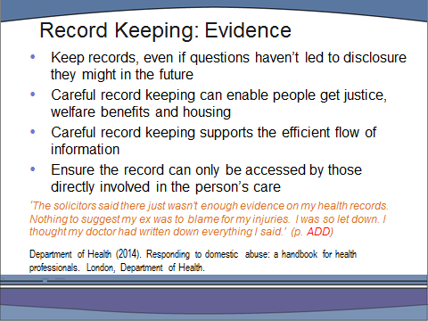

Slide 39

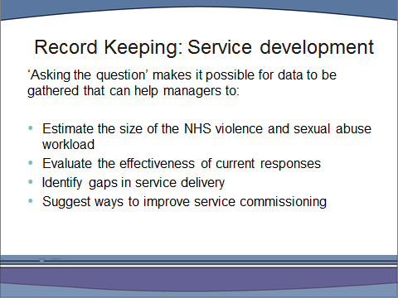

“So asking the question and keeping records of disclosures is important, but disclosing experiences of violence and abuse is often very difficult – especially doing so for the first time after years of not telling. It’s important that as practitioners you understand why children and adults may not tell anyone what is happening, or has happened, to them. This is particularly so because many survivors blame themselves for what occurred when they were children, for not stopping the abuse by running away, or for not telling someone what was going on. It can be useful for them to talk about this with someone who can help them understand how powerless children usually are in relation to their abusers.

Why do you think children don’t tell?”

Take suggestions from participants before putting up the list.

Slide 40

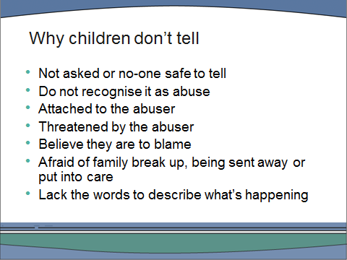

“Until they know differently, some children believe that what happens in their family happens to everyone. They may think of the abuse as affection, as punishment or just as part of growing up.

Some adults may continue not to recognise, or name, what has happened to them as abuse. They may have been abused as a child by a much loved father, or by the only person in their lives who provided the affection and attention they needed. They may have enjoyed being ‘special’ or may have accepted, even demanded, presents or treats in return for not telling. Or they may be in love with or completely dependent on a violent partner. Loyalty may keep them silent, as may guilt about their own ‘complicity’.

There are also children and adults who are silenced by fear. They may believe that the abuser will kill them or their mother or their children. They may know from their own experience that he is capable of violence. Where there is more than one abuser within the family (it may be both parents, or their step-father and an uncle/brother for example) or a wider network of abusers, they may believe that escape is impossible. They may have been threatened with the family breaking up, with deportation or homelessness if the abuser is sent to prison.

The same abuser may use different silencing strategies with different victims. Even within the same family one sibling may be a more needy child and praise and attention will ensure her loyalty, while her brother may be beaten into submission. Child sexual abusers ‘groom’ children to be their victims just as perpetrators of domestic abuse ‘groom’ their partners into dependency. The victim is isolated from other people, discouraged from having friends, told how much the abuser loves and needs them, and how special they are.

Individual abusers may effectively silence children but this is made much easier if they operate within a family, community or society where women and children have few rights, or where husbands and fathers are meant to be obeyed without question.

Abuse of power is easiest in closed communities where children have limited access to outsiders – as has been the case in residential schools and homes and in some religious sects. It can be hard for children to tell when this would involve talking to outsiders who may have negative or racist attitudes towards their culture or religion, or if they are afraid they would be rejected by their family and community. If being taken into care were the outcome of telling imagine the culture-shock of a residential children’s home for a 14 year old Bangladeshi girl from a strict Muslim family, or for a boy brought up as a Jehovah’s Witness.

Children may try to tell but not be able to make themselves understood. Adults may not listen, or too readily dismiss what children say. One little girl told her mum that she didn’t like it when grandpa put his “pencil” into her “pocket”, mum took it literally and told her not to be silly. Stereotypes and misconceptions may prevent children being heard when they try to tell. Consciously or unconsciously people may believe that ‘abuse doesn’t happen in respectable families’, or in Jewish/Hindu/Christian families, or in expensive private schools, or that it could be perpetrated by anyone they know or are related to, or by someone of the same sex”

Slide 41

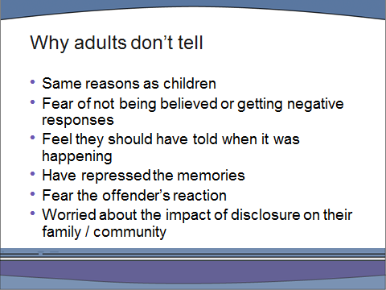

“People can repress memories to varying degrees:
- For some, the memories are constantly present with the survivor struggling to push them out of their mind.
- For others, they can be at the back of the mind occasionally flicking to the forefront.
- And others may have repressed the memories so completely that they only emerge when triggered by a significant event in later life, perhaps when the survivor has a child of their own, or when their child reaches the age they were themselves when the abuse started etc.”

Slide 42

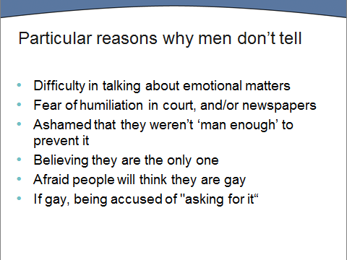

Use an example from your own clinical experience or discuss case example 6: A young man in pain.

Slide 43

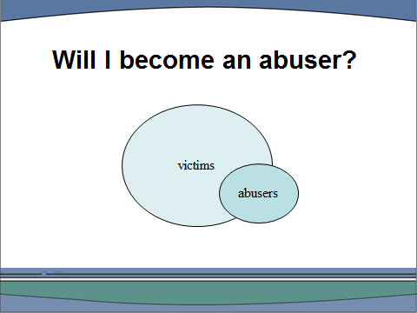

“Some male survivors are particularly fearful that they will themselves become abusers and it can be very helpful to reassure them that being abused does not turn people into abusers – although it is a common misconception that this is the case.

Research based on interviews with convicted sex offenders has found that around 50% of those who have abused a child claim that they were themselves sexually bused in childhood. These findings have been widely reported, and have led to a serious misunderstanding by many members of the public and survivors themselves – that 50% of children who are abused will grow up to abuse others.

This diagram shows how inaccurate this belief is. While you can see that half of the abusers are also victims of abuse, only a small proportion of all victims are also abusers. If there were some simple causal relationship between being abused and becoming an abuser, there would be a much greater number of women sexually abusing children. In fact, studies suggest that only between 5 and 10% of such abusers are women.* Also remember that some abusers abuse dozens of children in

their life-time; so for every abuser there are likely to be many more victims.”

“The clear message from research is that the majority of victims of sexual abuse,

including the majority of male victims, do not go on to sexually abuse others.” **

* Finkelhor, D (1984) Child Sexual Abuse: New Theory and Research, New York:

The Free Press.

** Maltreated children are significantly more likely to commit crimes (including

sexual crimes) as teenagers or young adults than those with no victimisation

history, but the experience of childhood physical abuse may be more

closely correlated with the development of sexual aggression in young men

than is sexual abuse. It seems it is the exposure to trauma, not sexual abuse

per se, that is significant in the emergence of sexually abusive sexuality.

Widom, Cathy Spatz (1995) Victims of Childhood Sexual Abuse – Later

Criminal Consequences, National Institute of Justice Research, Washington.

www.ojp.usdoj.gov/nij/pubs-sum/151525.htm

Tea break: Time – 2.45pm

Slide 44: Time – 3.00pm

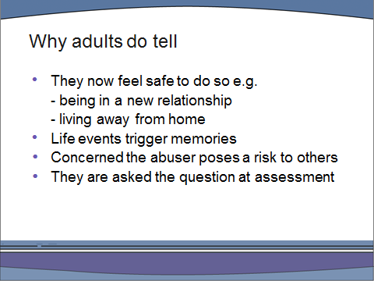

“
Some survivors choose to talk about their experiences at a point in their lives when they feel safe to do so. Others feel rather less in control of the disclosure because they are overwhelmed by memories and the feelings they bring with them. As we have already mentioned, life events may trigger memories. Less personal triggers can include TV programmes or encountering sexual abuse through work or friends. However, the triggering of memories does not necessarily lead to telling someone immediately – nor does being asked the question at assessment. Some survivors are so fearfulthat they will be ‘labelled mad and locked up’, or have their children taken off them, that they hide flashbacks and panic attacks, self-harm and phobias for years. Others simply decide to disclose at a later date when they’ve thought more about it, or had chance to decide who they feel most comfortable telling.

Survivors who have repressed or denied their own abuse may find memories are triggered by, for example, childbirth; their child reaching the age when they were abused themselves; the death of an abuser; or the death of a protective parent.

Some survivors will choose to disclose because they wish to protect other children. Others may never have considered that their abuser would abuse anyone else and only begin to think about this as they talk through their own abuse.

We do know that providing opportunities for survivors to speak about their abuse will increase the numbers who choose to disclose, at some point, although not necessarily at the assessment stage when first asked the question. However, we need to accept that for some service users mental health services do not represent a safe context for disclosure, particularly if they belong to groups which historically have been mistreated.. This includes lesbian, gay and trans-gender service users as well as those from Black and ethnic minority communities*. It is the responsibility of all of us to change this situation by educating ourselves about the issues for different service users and making mental health services safe, accepting and respectful for all who need them.”

*From Homebreakers to Jailbreakers: Southall Black Sisters, edited by Rahila Gupta. Zed Press, (2003). This book sets out to map that terrain where race and gender make competing claims. It covers a range of issues ranging from forced marriage to religious fundamentalism www.southallblacksisters.org.uk

Crossing the Boundary Black Women Survive Incest, Melba Wilson, Virago Press (1993) Discusses the plight of Black women in Britain who have had to deal with incest, and shows how the pressure to preserve the family and the myths about Black women have hindered the healing process.

Victims No Longer (Second Edition): The Classic Guide for Men Recovering from Sexual Child Abuse Mike Lew Harper (2004)

Can't Touch My Soul: A Guide for Lesbian Survivors of Child Sexual Abuse
Donna Rafanello Alyson Publications Inc (2004)

Exercise: In two groups of up to eight people (split into four if your group is larger than this) with flipchart. Allow 10 minutes.

Group 1:
Imagine a survivor of abuse who has decided they wish to disclose to their mental health worker. Take 10 minutes to write on the flipchart what feelings and thoughts they may be having just before making the disclosure.

Group 2:
Imagine a mental health worker hearing a disclosure of abuse. Take 10 minutes to write on the flipchart what they might be thinking and feeling as the disclosure occurs.

Take brief feedback from the two groups: acknowledge the anxieties as normal without getting bogged down in them.

This exercise has three purposes:
1. It allows staff to ventilate their anxieties about hearing a disclosure.
2. It encourages them to empathise more directly with the feelings of a survivor about to disclose.
3. It highlights the similarities of feelings on both sides.

Slide 45

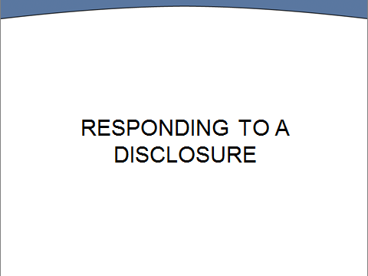

Slide 46

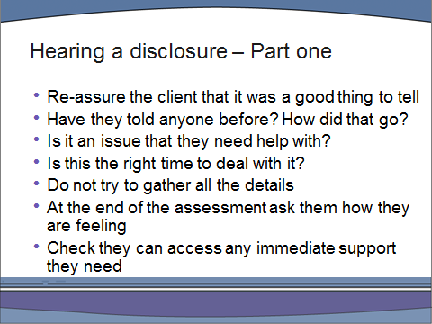

“The key points here are:
- Don’t assume, because someone has told you they were abused, that they will immediately require further help. They might have dealt with the abuse previously or already be getting help elsewhere. Asking whether they have told previously should clarify whether this is a first disclosure, a resolved issue for them or something in between.

- Few survivors will want to go into much detail at an initial assessment and this should be respected. Be clear that there will be further opportunities for them to talk about the abuse if they want to, either with you or someone else (and make sure that there is).

- It’s important to find out whether the service user thinks the abuse is a causal factor in their mental health difficulties. You are thereby treating the client as an expert on their own lives. You may not agree with their view – but this is probably not the best time to discuss it.

- It is also useful for the client to assess how problematic or intrusive difficulties relating to their abuse are for them. Someone who gets the occasional flashback may not want to open their personal can of worms. Abuse should be a problem for them before we try to fix it.

- Sometimes people are referred because other professionals think that they should be dealing with their past abuse when, in fact, they have too many other problems going on in their life at the moment for this to be appropriate.

- The survivor may have strong feelings about who supports them: they may have preferences about a male or female staff member, someone who shares their cultural background (or not), a mental health professional or a voluntary agency.”

Slide 47: Time –

“The issues are different if abuse is in the past or ongoing. If abuse is in the past this is what people need”

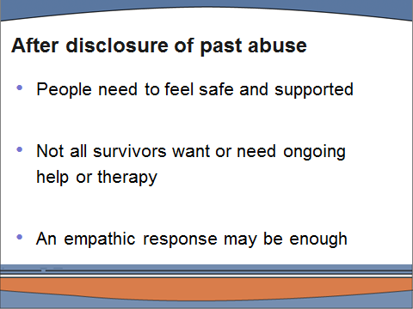

“The professional’s response to a disclosure of past abuse needs to be accepting, respectful and supportive – but staff do not need to have all the answers.

Some survivors will need support in disclosing to a partner or their family, if that is what they want to do. Staff should help them to prepare for the possible consequences/reactions following disclosure. A few voluntary agencies run support groups for partners or will offer one-to-one support”.

Slide 48:

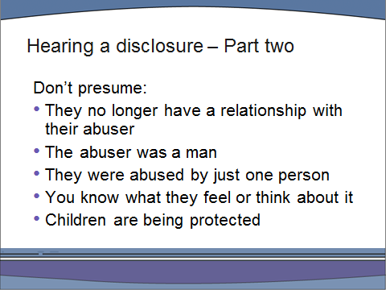

“If a wrong assumption is made by the professional at the outset, the client may struggle to say – “no, it wasn’t like that”. It is therefore important not to presume that what this person has to tell you will fit a stereotype of child abuse or domestic violence. For example, they may have been abused by a woman or by more than one person. As a child, they may have enjoyed the treats, attention or affection they received, or they may have experienced sexual pleasure during the abuse. Their abuser, or abusers, may still be involved in their lives: they may be doing the dutiful family thing and still having Sunday dinner with them.

If the abuser is a family member or part of the survivor’s community, then they may well still have considerable power. In the case of some service users, the abuser may also be their carer or partner.. Victims often still live in fear of threats made by the abuser even when the abuse is in the past, and
worries about the impact of disclosure on families or close-knit communities can be very powerful. It is not unusual for survivors to believe that ‘mum would die if she knew’ or ‘my family would disown me’.

In such circumstances, the potential consequences of disclosure may seem life-shattering: a survivor is risking the loss of all their support. They may also fear encountering a lack of understanding or even racist assumptions from professionals to whom they disclose.”

Case example 7 – A homeless Asian woman
Case example 8 - Disclosure by a Deaf survivor

Many will presume that they were the only victim and will not have considered that others may be at risk. They may be adamant that no-one else has been abused by their perpetrator only to find out later that their own child, or their siblings, have also been his victims. We’ll come back to safeguarding children and your responsibilities as a professional shortly.”

Raising safeguarding concerns about children with whom an abuser may have contact can be done without the survivor having to make a police statement about their own abuse. The fact that they have a choice needs to be clear to them. A mental health practitioner can contact children’s services on the survivor’s behalf or, if they wish to make a report to the police, first contact can be made by a worker who can arrange a time and place for an interview that is comfortable for the client, and accompany them if they wish. Where any official report is being considered, staff should first take advice from the safeguarding lead in the trust and should keep the survivor fully informed.

Slide 49 Time – 3.45pm

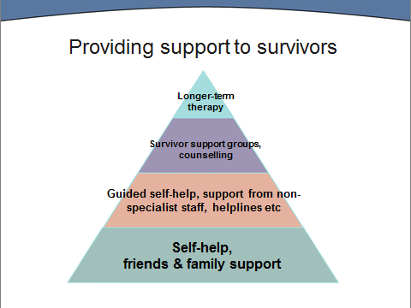

““Support for survivors operates at many different levels. Different mental health practitioners have important roles to play in responding appropriately at each of these levels.

All therapeutic work with survivors aims to reduce isolation, shame and self-blame and to increase self-worth and confidence. In the longer term such changes impact on depression, self-harm and substance abuse. Coping strategies are likely to be the last to change as these are what have helped survivors get by for so long, and they will continue to be needed until other changes are firmly established.

Not all survivors will want therapy. Some may regard their abuse as less significant to their current difficulties than other issues. Never underestimate the helpful impact you can have by just listening and responding supportively. This may be all they want/need initially. The most important thing is to empower survivors to make their own choices and to work at their own pace.

However, many survivors will, at some stage, choose to engage in individual counselling or therapy and some will undertake therapeutic group work. Any therapy that focuses on their abuse will churn up painful memories and feelings and they will be better able to cope with some supportive preparation. The safety planning we are going to discuss can be used to help survivors increase their safety if they are still at immediate risk of abuse, but it can also help people prepare for therapy or for involvement in a survivors group. It aims to increase individual’s confidence and competence in looking after their day-to-day well-being during stressful periods.”

Slide 50:

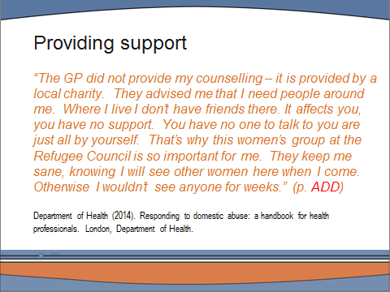

Slide 51

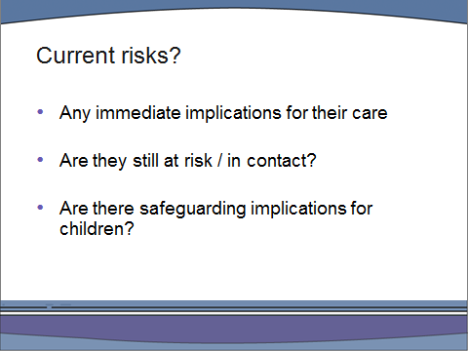

“You need to check out that the client is currently safe from abuse. If not, consider how they can protect themselves and whether there is a safeguarding vulnerable adults issue here. Telling someone about what happened can bring up a lot of feelings – even when not a lot has actually been said. Check out what support systems the client has and always carry the phone numbers for any out-of-hours support your trust provides as well as for the Samaritans and any local voluntary agencies that provide support for survivors.”

Slide 52: Time – 4.00pm
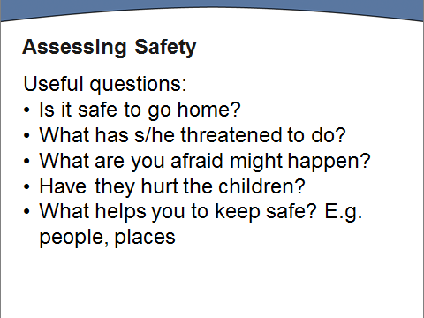

Slide 53
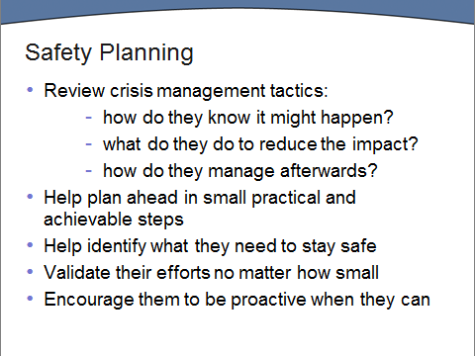

Slide 54

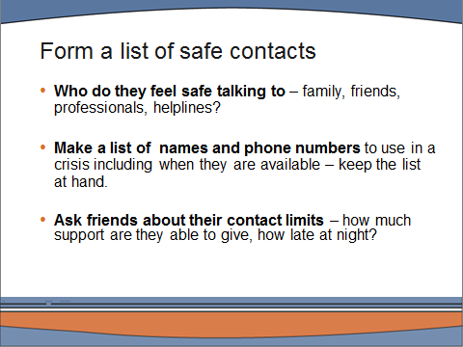

Slide 55

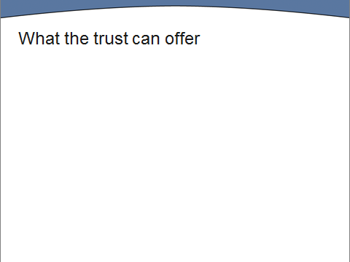

This slide has been left blank for you to insert
information and contact details for any services provided by your trust e.g. sexual abuse/eating disorders/personality disorder teams. You may want to invite people to say what services they have referred to.
Slide 56

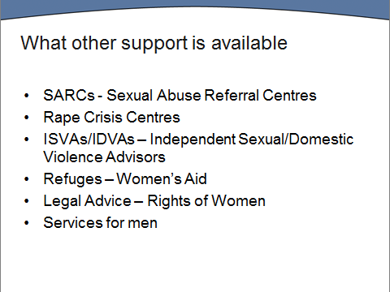

This slide shows the services that have broad coverage across the country. Use the links below to explore what they have to offer. However, you will need to check out what exactly is available in your Trust.

A Sexual Assault Referral Centre (SARC) provides services to victims of rape or sexual assault regardless of whether the victim reports the offence to the police or not. A directory is available on The Survivors Trust website: http://www.thesurvivorstrust.org/sarc/

Rape Crisis Centres have been supporting women and girls who have been raped or sexually abused since 1973. Information about local centres is available at: http://www.rapecrisis.org.uk/

An IDVA is a named professional case worker for domestic abuse victims whose primary purpose is to address the safety of ‘high risk’ victims and their children. An ISVA is trained to provide information on how the criminal justice process works and to provide support through the police and court process.

Women’s Aid is the key national domestic violence charity with over 300 affiliated refuges and other services 9including IDVAs) http://www.womensaid.org.uk/

Rights of Women provides women with free, confidential legal advice by specialist women solicitors and barristers http://rightsofwomen.org.uk/

Services specifically for men include: http://www.mensadviceline.org.uk/; http://www.mankind.org.uk/; http://www.survivorsuk.org/

Slide 57

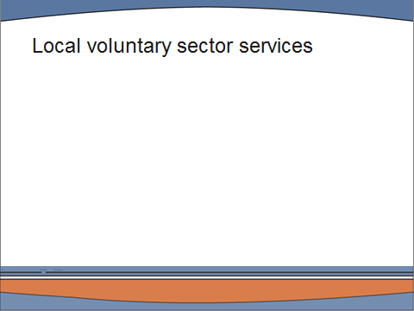

This slide has been left blank for you to insert
information and contact details for any voluntary sector services in your area. You may want to invite people to say what services they have referred to.
Slide 58: time – 4.20pm

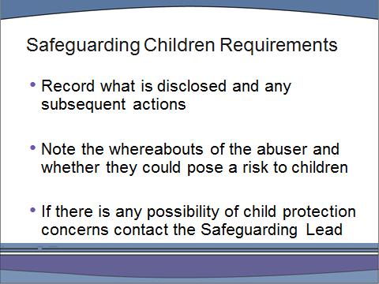

- Trainers should be familiar with their local Safeguarding Children and Adults Procedures and have copies available in the room.
- Trainers should have liaised with their Safeguarding Leads to ensure that they are aware of this training. Their name and contact details should be provided.

“If there is a disclosure of child abuse, the abuser is in contact with children and the client gives you information that identifies any of the parties, then there is a child protection issue to be raised. This is a professional, legal responsibility.

The local Safeguarding Children Board has a Procedures Manual providing guidelines on the required response of staff dealing with disclosures of historical abuse. In brief, they require you to do what is said on the slide.

As soon as it is apparent that an adult is revealing child abuse, you must record what is said by the service user and any subsequent action you take.

- It is important to record accurately what is said. Written records need to include:
- Brief details of the abuse as disclosed by the service user and any subsequent action taken.
- Who the service user has previously disclosed to
- The date and the staff member’s legible signature or name

Always take notes that use reported speech: ‘Matthew said his Uncle was a sadist’ or put it in quotation marks: Matthew said “My uncle was a sadist” and not ‘Matthew’s Uncle was a sadist’.
If the services user indicates any possibility that a child may be at risk, then it has to be reported to Children’s Services. You have a responsibility to ensure this happens. The service user may want to be involved in reporting it themselves and they should be supported to do so if they wish but, if they don’t, you need to report it anyway.

Children’s Services will conduct their investigation and involve the police in any current child protection concern. They will ask the service user whether they want to report their own abuse to the police and reassure them that the police are able and willing to undertake such work even for those adults who are vulnerable as result of their mental health or learning difficulties, or who are worried that they won’t be taken seriously.

If the survivor wants to make a police statement, you should inform them that police forces have specialist Child Abuse Investigation Units experienced in dealing with historical abuse. If there is no identified child at risk this is, in smaller police forces, dealt with by the CID, who will liaise with the child protection department, if necessary. The police acknowledge that effective investigation and successful prosecution is hampered by the passage of time. Crucial evidence may no longer be available and an absence of corroboration may be a significant hurdle to prosecution. However, they emphasise that information given could support the allegations of others or enable another enquiry to proceed.

Remember, it is not necessary for a service user to make a police complaint about their own past abuse in order to protect children – a child protection concern can be raised with Children’s Services quite separately. A written account of the events/concerns may be necessary, but this is not the same as making a police statement.

If unsure, before undertaking any of the above you may like to seek advice from your team leader/ward manager and, if necessary, the safeguarding lead in your trust.”

Slide 59 Time: 4.30pm

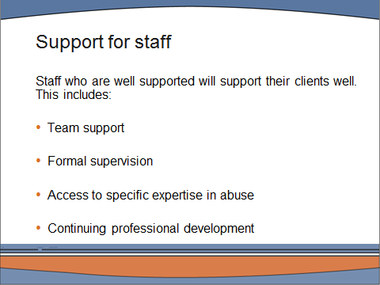

“In order to support service users appropriately, staff themselves need to be well supported. Hearing about the violence and abuse in peoples lives and
acknowledging its impact takes its toll on staff too. To avoid being overwhelmed - and to be enabled to work in an open, empowering way - requires having access to four different kinds of support.

First up is the informal support of colleagues including regular discussion of cases and opportunities for ‘off-loading’ after a difficult session. Give an example from your own experience.

Second is formal clinical supervision which should be regular and quite distinct from line-management meetings. Whether in a group or one-to-one, clinical supervision is the opportunity to reflect on relationships with clients, including on one’s own feelings and practice. Mention here your trust’s supervision policy.

Third is access to specialist expertise in abuse.
Trauma and abuse are areas in which some practitioners have developed particular expertise and are able to provide case consultancy to others.

Fourth is the need for continuing professional development. Mention here who else/what else is available in your trust e.g. clinical seminars. Continuing professional development can take a number of forms. Practice development forums can provide an excellent opportunity to share learning. There are formal training courses at a number of levels.

Mention other relevant training provided in your trust or CPD courses at local universities.

Your own reading will play a big part in your professional development. It can be hard to find time to locate and read academic articles – but the reference list provided to you by email includes lots of links which will take you to a wide range of accessible articles covering the evidence-base for this training with just one click.”

Slide 60

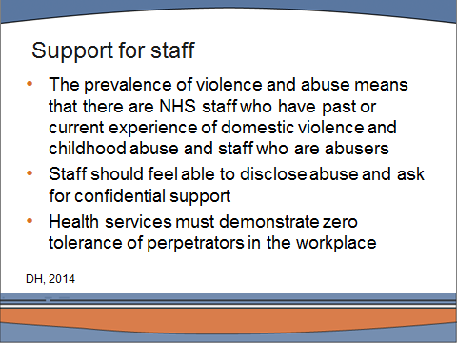

Slide 61

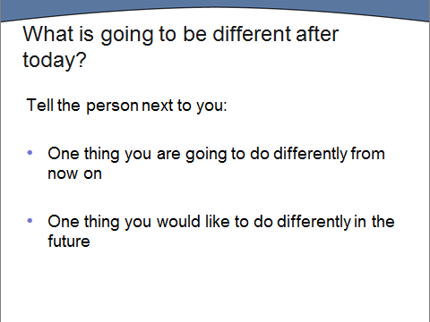

Slide 62

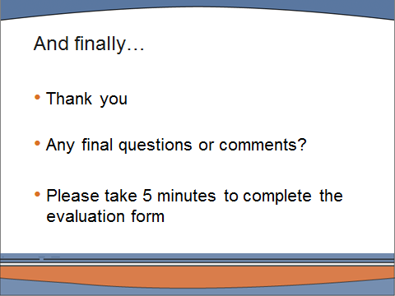

Closing circle

You may like to end the day by asking participants to each name one thing they will take away from the day. Whilst trainees are still seated, hand out evaluation forms to be completed before leaving.

Your trust will probably have a standard evaluation form that is completed at the end of every training event. You also have a copy of the specially designed evaluation form for this course in your trainer’s pack. It can also be downloaded from: www.dmss.co.uk.

Case Examples

The trainer’s notes indicate the places where a case study example might help to illustrate a point. The examples here have been drawn from research and clinical experience. Where possible use your own case studies to illustrate specific points as these will be more familiar to you but do remember to make sure they are sufficiently disguised to ensure client confidentiality.

1: When people are not asked the question…or their disclosures are ignored

- Melanie was in her late 30s and had been using services for 10 years before she started making connections between what had happened to her in childhood and her mental health as an adult. She had struggled all her life with overwhelming rage, she had very little trust in other people – expecting them to let her down at every turn – she knew she was suspicious, jealous and had destroyed relationships by trying to be in control. What she didn’t understand was ‘why’: “The biggest problem for me, I think, was nobody asked me. …so my perception was these things happened in my childhood, and I’m just as bad now as I was then. It wasn't: ‘I might be having trouble because those things have happened’. It just showed me how bad I was.”

- A patient disclosed at the assessment stage of her admission to hospital that she had been abused as a child (although the question wasn’t asked)… and staff ‘did nothing’. After three weeks in hospital, she was discharged and, at the discharge planning meeting, when asked “is there anything else we need to consider for you?” she mentioned the abuse again …”Well, like I said when I was admitted, I’d like help to deal with my past abuse”. She had spent three weeks receiving care for symptoms without any acknowledgement of what she believed were the underlying causes

- At 46 David had been involved with mental health services for over 30 years. He was sexually abused as a teenager and describes himself as having had a breakdown when he was 17. “All that was treated at that time was the effects…the symptoms. My mum did say to them about [the abuse] and they, they were just like ‘oh that's not really an issue’, what the issue is is dealing with the mood swings and trying to control those with medication rather than what was causing them.’ Devon Man here - CSA

2: Not being believed

Hayley who had been sexually abused by her father, was taken into care but sent on ‘home leave’ at the weekends where the abuse continued. She was later sexually abused by two male residential social workers and became pregnant at 14. She threatened to report one of the workers who was abusing her – he told her she wouldn’t be believed because of her long history of disruptive behaviour. She threatened to burn the place down if he did it again – and he did – so she set fire to her room. She still wasn’t believed and she was transferred to a secure unit.

As an adult, she kept trying to find someone who would listen to her story but her lengthy mental health records (with a variety of diagnoses) and previous complaints to Social Services had got her labelled as someone who ‘didn’t tell the truth’.

On one occasion, after taking an overdose, she ended up in an A&E department some distance from where she lived. So when she told her story this time to nurses and a police officer - who hadn’t heard of her before – her allegations were taken seriously. It was discovered that one of the social workers who she was accusing had previous convictions – and was currently working in a children’s home in another area. He was quickly suspended from his job.

This case went to court and a number of other victims came forward whom he had abused in the care situation. She later sued the local authority for her treatment in care and awarded considerable financial compensation.

3: Issues of control

William grew up in a strongly Catholic environment. His father ruled the family of 2 younger brothers and one older sister with, to quote William ‘with a hand of iron’.

Any deviations from the prescribed rules of conduct would be severely punished. Everything would have to be exactly as his father required; manners at the dinner table, lights out, getting ready for school. Half an hour TV no more no less, that their father chose for them, and obligatory bible readings prior to bed. Within a very rigid patriarchal family structure there was no scope for questioning, or challenge, or rebellion. William cannot remember having a single conversation with his father, only instructions and commandments.

As an adult William is isolated and preoccupied with quite severe OCD, involving various sources of contamination that worry him. These result in large parts of the day being consumed by rituals.

4: Psychosis and escape

Kate is 43 and has been married for 12 years and during most of this time has had brief admissions to Psychiatric Hospital in the summer months. She has been diagnosed as an ‘intact Schizophrenic’ who is medication compliant. Recently a Social Worker wondered about these admissions and through conversations with her and her partner found out that:

- Her husband is a teacher in the local school.
- He decides what she wears, eats, when she goes out, what she does and controls her medication. He monitors her movements, and believes he is an expert ‘carer’.
- In turn she has become an ‘expert’ at minimising conflict and accommodating his likes and dislikes.
- He has been violent in the early years of their marriage when Kate tried to leave, however he is not currently violent.

On admission she is described as enraged, very fearful, and difficult to nurse; she has been in secure care areas several times because of lashing out impulsively at staff.

5: Traumatic memories in her ‘80s

Martha, at the age of 84, started to talk for the first time about being sexually abused by her brother.

For most of her life Martha had coped with her memories by keeping busy to block them out. She worked full time, raised her children, and then took on voluntary work when her children were older. She filled her life and was known as a ‘pillar of the community’ who could be relied upon to help out anyone in need.

At 84 she required a hip replacement and was immobilised. Sitting still for long periods brought about time for reflection … and reflecting upon her past brought back memories of the abuse. She started talking about the abuse as if it had happened recently and struggled with flashbacks, anxiety and depression. She asked her GP if he could refer her to a counsellor but he suggested this would only ‘stir things up further’ and prescribed Prozac instead.

6: A young man in pain

Andrew's father was an alcoholic and was violent to his wife and children. Both the drinking and the violence worsened as his business began to run into trouble, when Andrew was about 10. When Andrew was 14, he took on a Saturday delivery job and was sexually abused on several occasions by the male boss. He is very reluctant to discuss this and no other details are known.

Andrew himself started drinking and using drugs; mainly cannabis based, from the age of 15, and, failed his GCSEs largely as a result. After school a pattern developed in which he would hold down a job for a few months, but invariably slip back into drinking. Eventually, after some violent rows at home, his mother threw him out and he slept rough for a few months. At around this time he was first referred to the psychiatric services for outpatient appointments and was diagnosed as depressed.

About two years later, Andrew began to develop the first signs of what was diagnosed as 'paranoia' when he started to started to believe that he was ‘famous’ and that various people were ‘stealing his music’. He also described frightening experiences of looking in the mirror and seeing his father's face reflected back at him.

7: A homeless Asian woman

Farzana was a young Bangladeshi woman who had come to England three years previously with her new husband. They lived in a neighbourhood where her husband had relatives and many of her neighbours had originally come from villages close to where she had grown up. She had two daughters – a toddler and a baby, and hadn’t had a paid job since she got married. Her English wasn’t very good and she rarely went out without her husband.

When her husband became increasingly violent she was both very angry and very frightened. She threatened to go to the police but he laughed at her. She went to her in-laws for help; they didn’t believe her and warned her that if she brought disgrace on the family, they would disown her. Her GP offered her anti-depressants. Some months later, she sought help at the local council offices and she and her children were placed in a bed and breakfast for homeless families.

She was desperately lonely, living on benefits and terrified of her children being abducted by her husband. She had lost an extended family, community, home and security and her mental health was fragile. The only professional - she told the whole story to was a housing support worker she trusted.

With help from her housing worker Farzana slowly made a new life for herself and her children: she got a flat – and an injunction to prevent her husband’s constant harassment – a nursery place for her youngest and a college place for herself. She was immensely proud of being a good mother and of having protected her children – but the cost to all of them was immense.

8: Disclosure by a Deaf survivor

A deaf woman in her ‘40s contacted Childline by minicom (text talk). She told them that she had been sexually abused by two of her - then teenage - uncles when she was nine and ten (one uncle was deaf and the other hearing). She had recently seen them at a family wedding and had been horrified to see how they were coming on to a young cousin, getting her drunk and ‘touching her up’.

She didn’t want to go to Social Services as she was sure the case would be given to a social worker who was the hearing daughter of deaf parents in the same community. She agreed to be put in touch with a counsellor from Rape Crisis but insisted they had to find a sign language interpreter from another city. Over a series of meetings she talked about her abuse. Her (deaf) parents had known what had happened to her but they were afraid that if they tried to do anything official they would be accused of being incapable parents for letting it happen, and that their children might be ‘taken off them’, as had often happened to deaf parents in the past. She was therefore told never to speak of it. She still believed that social workers were not to be trusted. Also she was not prepared to ‘shop’ her deaf uncle in case he was sent to prison and would therefore name neither of them.

However, with the support of her mum - who was now in her ‘70s - she confronted her Deaf uncle and told everyone in the family what both uncles had done to her when they were teenagers. She told them it was their job to make sure it didn’t happen again. She also became a campaigner on the subjects of both child abuse and domestic violence within the Deaf community. She was invited to speak at conferences and she spoke out about her own experiences.

Recommended reading for trainers

Violence and abuse: Causes in context
Barnados (2014). Puppet on a string: The urgent need to cut children free from sexual exploitation. Ilford, Barnados, www.barnardos.org.uk.

Burrowes, N. and T. Horvath (2013). The rape and sexual assault of men – a review of the literature. www.nb-research.co.uk, Survivors UK.

Hearn, J. and A. Whitehead (2006). "Collateral damage: Men’s ‘domestic’ violence to women seen through men’s relations with men." Probation Journal 53 (1): 38–56.

McNeish, D. and S. Scott (2014). Women and girls at risk: Evidence across the life-course. . London, Barrow Cadbury Trust, LankellyChase Foundation and Pilgrim Trust.

Williams, J., D. Stephenson and F. Keating (2014). "A tapestry of oppressions." The Psychologist 27(6): 406-409.

World Health Organization (2013). Global and regional estimates of violence against women: prevalence and health violence (Summary). Geneva, World Health Organization.effects of intimate partner violence and non-partner sexual

Violence and abuse: Consequences

