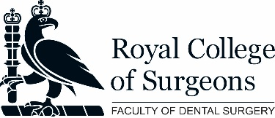
This is to certify that XX, GDC number xxxxx, has completed Children’s Oral Health Advice Module 1.

Aim: To improve the knowledge of the general public and early years healthcare workers regarding children’s oral health.

Total time spent: XX minutes (to be completed by learner with reference to the e-LfH certificate)

Educational objectives: | By the end of this module, the learner can:  - List and describe the timings of tooth eruption  - Identify the main causes of tooth decay  - Explain two ways of preventing tooth decay  - List and describe the causes and prevention of tooth erosion  - Outline the basic management of a knocked-out tooth
Learning content: | This session is designed to help the learner become confident in providing child oral health advice. Tooth development and problems including tooth decay, erosion and trauma are discussed and evidence-based preventive advice is provided.
Development Outcomes: | This course meets the criteria for the GDC’s development outcome (to be completed by learner with reference to GDC documentation).
Provider validation: | The Faculty of Dental Surgery of the Royal College of Surgeons of England confirm that the information provided on this certificate is full accurate.
Quality assurance: | This CPD is subject to quality assurance by Professor Nigel Hunt of UCL Eastman Dental Institute.

