I work in a care home. How do I register to access the Dysphagia Guide e-learning resource?

- Go to: portal.e-lfh.org.uk

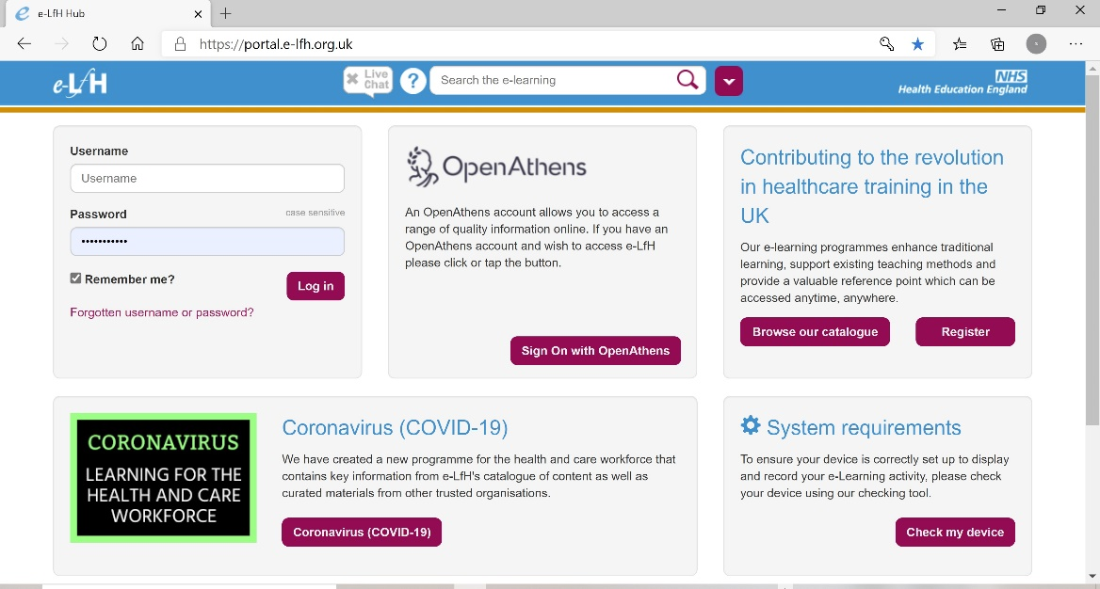

- Select the Register button

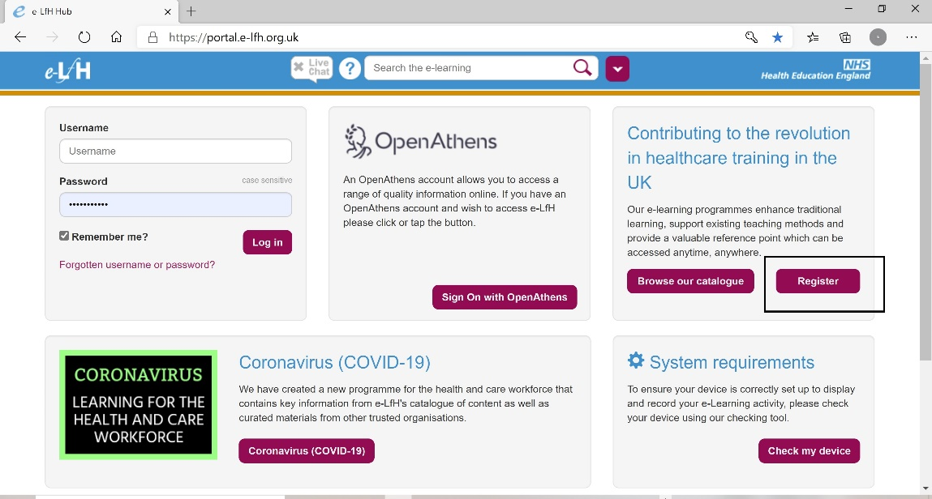

- Type in your email address twice and select Register. Please note, you can use either your personal or work email address.
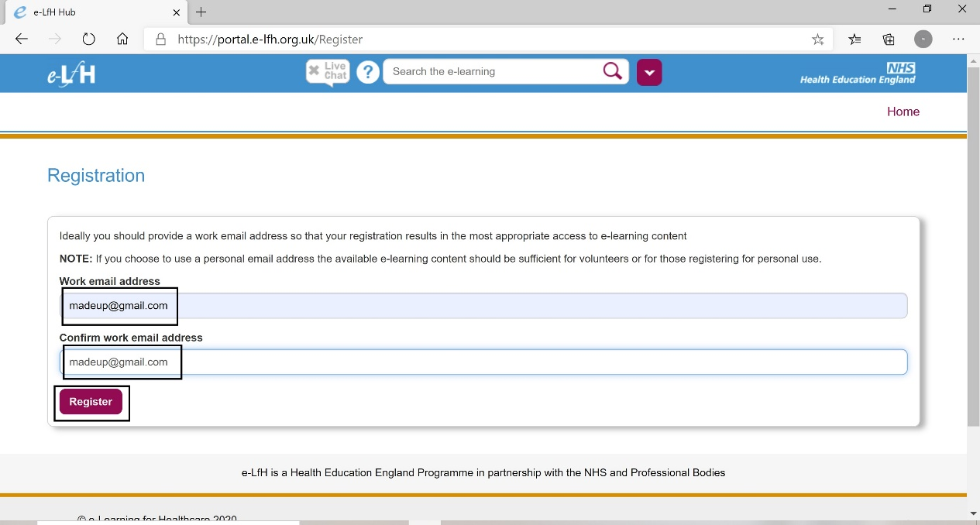

- If you are a care home worker or work for a non-NHS organisation and you do not know the registration code, you will need to choose ‘None of the above apply to me’ and select Continue.
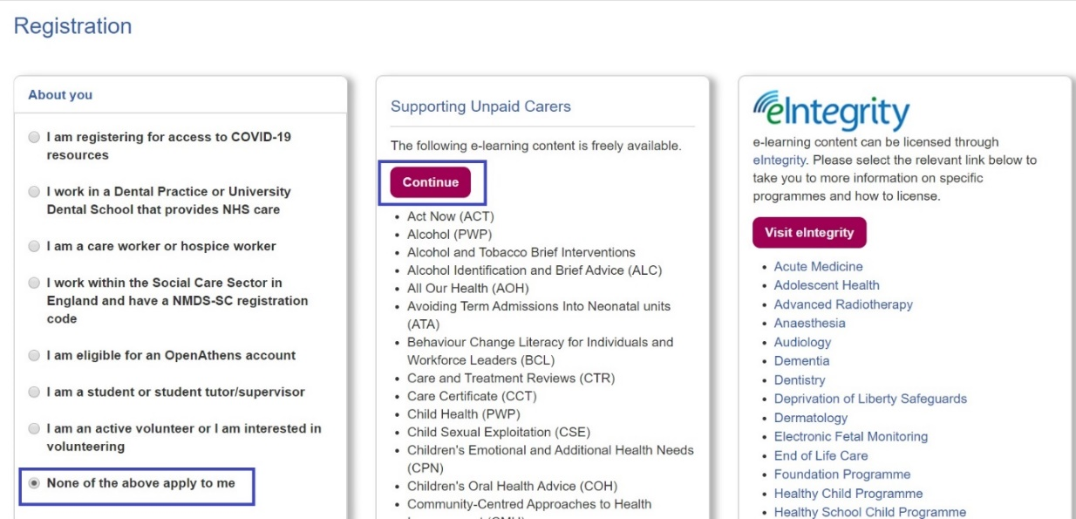

- Type in your personal details, region and country. Under ‘role’, type in your role/select from the options presented and select Register
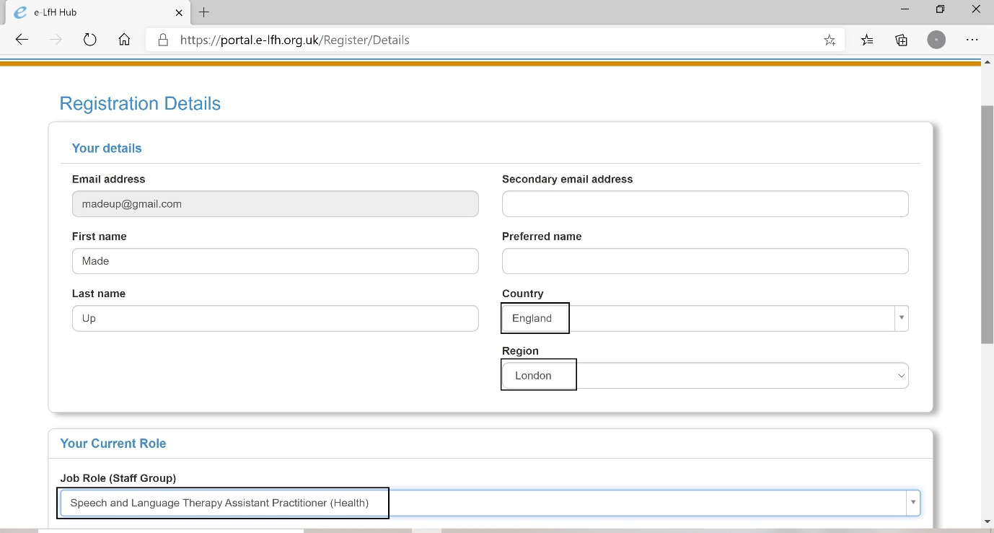

- You will receive a confirmation that your registration is in progress.

You will be assigned a temporary password until you log in for the first time and change it.
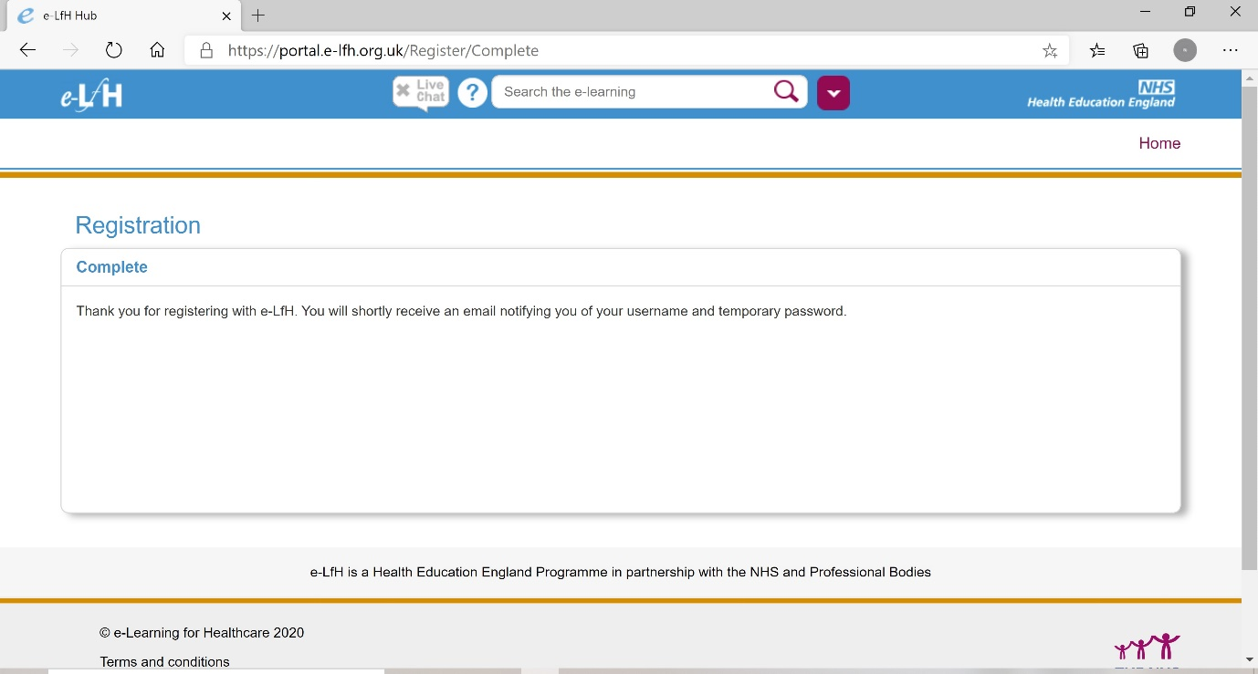

Soon afterwards, you will be sent an email with your log in and password.

