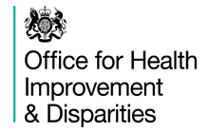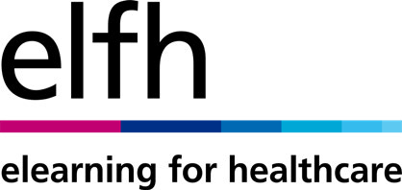

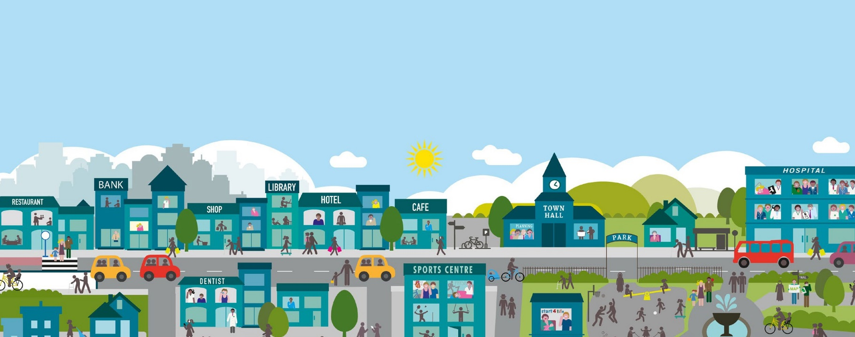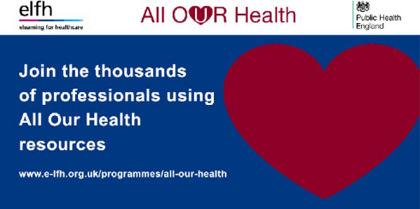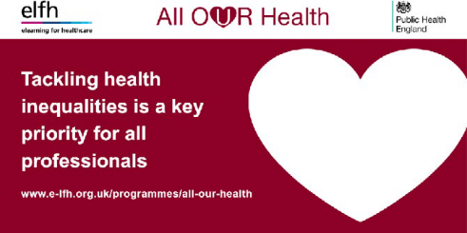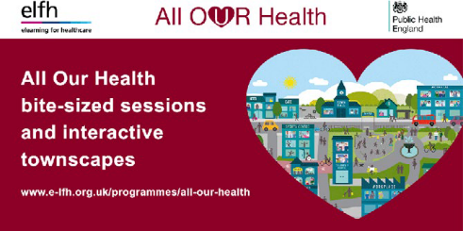

**All Our Health communications toolkit**

**Facebook posts**

**Please copy and paste the text below with the accompanying GIF animation for your Facebook activity.**

**01 Facebook post**

**02 Facebook post**

**03 Facebook post**

Join the thousands of professionals already accessing the All Our Health elearning programme to increase your knowledge on key public health issues. Free sessions and interactive townscapes are available from Health Education England elearning for healthcare and Public Health England: h[ttps://](https://www.e-lfh.org.uk/programmes/all-our-health/) [www.e-lfh.org.uk/programmes/all-](https://www.e-lfh.org.uk/programmes/all-our-health/)

[our-health/](https://www.e-lfh.org.uk/programmes/all-our-health/)

Health Education England elearning for healthcare has worked with Public Health England to develop

a range of trusted resources on key public health issues including obesity and air pollution to help professionals improve the nation’s health. For more information and to access the resources, visit: h[ttps://](https://www.e-lfh.org.uk/programmes/all-our-health/) [www.e-lfh.org.uk/programmes/all-](https://www.e-lfh.org.uk/programmes/all-our-health/)

[our-health/](https://www.e-lfh.org.uk/programmes/all-our-health/)

A wide range of trusted resources on key public health issues are now available via the All Our Health elearning programme. Developed by Health Education England elearning for healthcare and Public Health England, the brief sessions and interactive townscapes aim

to improve your skills in reducing health inequalities. Visit: h[ttps://](https://www.e-lfh.org.uk/programmes/all-our-health/)

[www.e-lfh.org.uk/programmes/all-](https://www.e-lfh.org.uk/programmes/all-our-health/)